**A PROJECT REPORT ON**

XXXXX **Online meeting Media** XXXXX

**Submitted to XXXXXX University for the partial fulfillment of the   
requirement for the**

**Award of Degree for**

XXXXXXXXXXX **Course Name** XXXXXXXXXXXXX

**Done By**

# Mr. / Miss. XXXXXX

## XXXXX Institute of Management & Computer Sciences

**Hyderabad**

**CERTIFICATE**

This is to certify that Mr. / Miss XXXXXXXXXX, bearing Roll No. XXXXXXXXXXX have developed Software Project Titled XXXXXXXXXXXXXX for XXXXXXXXX **SOFTWARE SOLUTIONS** as a partial Fulfillment for the award of the Degree of XXXXXXXXXXXXXX.

**HEAD OF DEPARTMENT** **PRINCIPAL**

**XXX institute of Management**

**&**

**Computer Sciences**

**EXTERNAL**

#### ACKNOWLEDGMENT

My express thanks and gratitude and thanks to Almighty God, my parents and other family members and friends without whose uncontained support, I could not have made this career in XXXXXXXXXX.

I wish to place on my record my deep sense of gratitude to my project guide, **Mr. / Miss XXXXXXXXXX, XXXXX Software Solutions, Hyderabad** for his/her constant motivation and valuable help through the project work. Express my gratitude to **Mr. / Miss XXXXXXXXX**, Director of XXXXXXXXX **Institute of Management & Computer Sciences** for his/her valuable suggestions and advices throughout the XXXXXXXX course. I also extend my thanks to other Faculties for their Cooperation during my Course.

Finally I would like to thank my friends for their cooperation to complete this project.

XXXXXXXXXXXX

(XXXXXX)

**ABSTRACT**

The main concept of Online Meeting with clients is developing the conference on the net. We can compare the Online Meeting with clients with the Telephone Conference. Normally in Telephone Conference, there will be more than two users connected at a time and all the users are able to here word from any one of the user. So implementing the same concept on the Net is nothing but Online Meeting with clients .This project is used to Conduct conferences with their employees. So they can get online decisions from employees from the different branches of the company. Another advantage is that the company is having branches throughout the country. So this will help them to communicate business affairs of the company and live meetings and conferences between their directors. They can conduct board of directors meeting.It will give On-line solutions from the superiors to the employees.

This project is used to:

* Conduct conferences with their employees. So they can get online decisions from employees from the different branches of the company.
* The advantage is that the company is having branches throughout the country. So this will help them to communicate business affairs of the company and live meetings and conferences between their directors. They can conduct board of directors meeting.
* It will give On-line solutions from the superiors to the employees.

**CONTENTS**

1. **INTRODUCTION**
   1. INTRODUCTION TO PROJECT
   2. ORGANIZATION PROFILE
   3. PURPOSE OF THE PROJECT
2. **SYSTEM ANALYSIS**
   1. INTRODUCTION
   2. ANALYSIS MODEL
   3. STUDY OF THE SYSTEM
   4. HARDWARE & SOFTWARE REQUIRMENT
   5. PROBLEMS IN EXISTING STSTEM
   6. SOLUTION OF THESE PROBLEMS IN PROPOSED SYSTEM
   7. INPUT & OUTPUT
3. **FEASIBILITY REPORT**
   1. TECHNICAL FEASIBILITY
   2. OPERATIONAL FEASIBILITY
   3. ECONOMIC FEASIBILITY
4. **SOFTWARE REQUIREMENT SPECIFICATIONS**
   1. FUNCTIONAL REQUIREMENTS
   2. NON-FUNCTIONAL REQUIREMENTS
   3. PERFORMANCE REQUIREMENTS
5. **SYSTEM DOVELOPEMENT ENVIRONMENT**
   1. INTRODUCTION TO JAVA
   2. SERVLETS,JSP
   3. JDBC
   4. HTML,JAVASCRIPT
   5. ORACLE 10g
6. **SYSTEM DESIGN**
   1. INTRODUCTION
   2. NORMALIZATION
   3. DATA DICTIONARY
   4. E-R DIAGRAM
   5. DATA FLOW DIAGRAM
   6. ACTIVITY DIAGRAM
   7. USE CASE DIAGRAM
   8. SEQUENCE DIAGRAM
   9. CLASS DIAGRAM
7. **OUTPUT SCREENS**
8. **SYSTEM TESTING AND IMPLEMENTATION**
   1. INTRODUCTION
   2. STRATEGIC APPROACH OF SOFTWARE TESTING
   3. UNIT TESTING
   4. TEST CASES
9. **SYSTEM SECURITY**

9.1. INTRODUCTION

* 1. SECURITY IN SOFTWARE

1. **CONCLUSION**
2. **FUTURE ENHANCEMENTS**
3. **BIBLIOGRAPHY**

**Chapter 1**

**INTRODUCTION**

* 1. **INTRODUCTION TO PROJECT**

Communication is very much essential and the importance of it is increasing from time to time along with the evolution of human needs. Developing Online meeting for an Organization.

The main concept of Online meeting is developing the conference on the net. We can compare the Online meeting with the Telephone Conference. Normally in Telephone Conference, there will be more than two users connected at a time and all the users are able to here words from any one of the user. So implementing the same concept on the Net is nothing but Online meeting.

**1.2: ORGANIZATION PROFILE**

### SOFTWARE SOLUTIONS

XXXXXXX Software Solutions is an IT solution provider for a dynamic environment where business and technology strategies converge. Their approach focuses on new ways of business combining IT innovation and adoption while also leveraging an organization’s current IT assets. Their work with large global corporations and new products or services and to implement prudent business and technology strategies in today’s environment.

**XXX’S RANGE OF EXPERTISE INCLUDES:**

* Software Development Services
* Engineering Services
* Systems Integration
* Customer Relationship Management
* Product Development
* Electronic Commerce
* Consulting
* IT Outsourcing

We apply technology with innovation and responsibility to achieve two broad objectives:

* Effectively address the business issues our customers face today.
* Generate new opportunities that will help them stay ahead in the future.

**THIS APPROACH RESTS ON:**

* A strategy where we architect, integrate and manage technology services and solutions - we call it AIM for success.
* A robust offshore development methodology and reduced demand on customer resources.
* A focus on the use of reusable frameworks to provide cost and times benefits.

They combine the best people, processes and technology to achieve excellent results - consistency. We offer customers the advantages of:

**SPEED:**

They understand the importance of timing, of getting there before the competition. A rich portfolio of reusable, modular frameworks helps jump-start projects. Tried and tested methodology ensures that we follow a predictable, low - risk path to achieve results. Our track record is testimony to complex projects delivered within and evens before schedule.

**EXPERTISE:**

Our teams combine cutting edge technology skills with rich domain expertise. What’s equally important - they share a strong customer orientation that means they actually start by listening to the customer. They’re focused on coming up with solutions that serve customer requirements today and anticipate future needs.

**A FULL SERVICE PORTFOLIO:**

They offer customers the advantage of being able to Architect, integrate and manage technology services. This means that they can rely on one, fully accountable source instead of trying to integrate disparate multi vendor solutions.

**SERVICES:**

XXXXXX is providing its services to companies which are in the field of production, quality control etc with their rich expertise and experience and information technology they are in best position to provide software solutions to distinct business requirements.

**1.3. PURPOSE OF THE PROJECT**

The purpose of this Software Requirement Specification (SRS) is to help the project.This project is used to Conduct conferences with their employees. So they can get online decisions from employees from the different branches of the company.

We can compare the Online meeting with the Telephone Conference. Normally in Telephone Conference, there will be more than two users connected at a time and all the users are able to here words from any one of the user. So implementing the same concept on the Net is nothing but Online meeting.

**Chapter 2**

**SYSTEM ANALYSIS**

**2.1. INTRODUCTION**

Communication is very much essential and the importance of it is increasing from time to time along with the evolution of human needs. Developing Online meeting for an Organization.

The main concept of Online meeting is developing the conference on the net. We can compare the Online meeting with the Telephone Conference. Normally in Telephone Conference, there will be more than two users connected at a time and all the users are able to here words from any one of the user. So implementing the same concept on the Net is nothing but Online meeting

**1.1) Present System:**

Conferences will take part a vital role for any of the national wide company. Because the company is having branches through out India, they need to conduct conferences between their employees and to conduct board of directors meeting among their directors, general managers.

Normally conferences will be conducted in some place owned by company or in some conference hall. The person, who has to participate in the conference, has to travel all the way to participate in the conference. So it will be very risky to travel for the persons, and it is risky work for the company also to provide all the felicities to persons. Now a day wherever you see so many strikes are going. In that case to participate in any important conference or to conduct any conference will be very tedious. All this may lead to loss of company and time taking matters. So here the company is decided to develop their conferences on the net itself.

Out of many solutions for Communication, the best one is still the physical LAN connection. It provides efficient solution with minimal overheads.

For exchange of information between systems, network has to be configured properly to allow the access to the information in one system to others. This when used in right sense, will be very much appreciable and productive. But in reality, this also helps the users to perform malicious activities, knowingly or unknowingly. This causes serious problems in the organization.

There are many commercial software products are available, which can do the all the required things to ensure smooth functioning of the organizations network. These also provide good control over the information exchange. But obviously these products come at premium price tags. Overall these software products are not economically feasible to the small and medium sector organizations.

**1.2) Why to develop Online meeting:**

Now a day’s time is becoming more and more precious.100% industries are computerized and there is a vast development in industries either in the public sector or in the private sector. The common transactions for any company are *sales* and *purchases.* So most of the companies now days made on line sales and purchases. So distributors, customers and companies can continue their business dealings using this on-line sales and purchases. By this they can save their valuable time.

Through this they will be able to make conferences with their clients (distributors) or with their customers with timely updates of the company business. So they can improve their products with respect to the customers view. This will help them to become a number one position in the current market.

Another advantage is that the company is having branches throughout the country. So this will help them to communicate business affairs of the company and live meetings and conferences between their employees and directors. They can conduct board of directors meeting It will give On-line solutions from the superiors to the employees.

**2.2. ANALYSIS MODEL**

The model that is basically being followed is the SPIRAL MODEL, which states that the phases are organized in a linear order. First of all the feasibility study is done. Once that part is over the requirement analysis and project planning begins. If system exists one and modification and addition of new module is needed, analysis of present system can be used as basic model.

The design starts after the requirement analysis is complete and the coding begins after the design is complete. Once the programming is completed, the testing is done. In this model the sequence of activities performed in a software development project are: -

* Requirement Analysis
* Project Planning
* System design
* Detail design
* Coding
* Unit testing
* System integration & testing

Here the linear ordering of these activities is critical. End of the phase and the output of one phase is the input of other phase. The output of each phase is to be consistent with the overall requirement of the system.

SPIRAL MODEL was defined by Barry Boehm in his 1988 article, “A spiral Model of Software Development and Enhancement. This model was not the first model to discuss iterative development, but it was the first model to explain why the iteration models.

As originally envisioned, the iterations were typically 6 months to 2 years long. Each phase starts with a design goal and ends with a client reviewing the progress thus far. Analysis and engineering efforts are applied at each phase of the project, with an eye toward the end goal of the project.

**The following diagram shows how a spiral model acts like:**

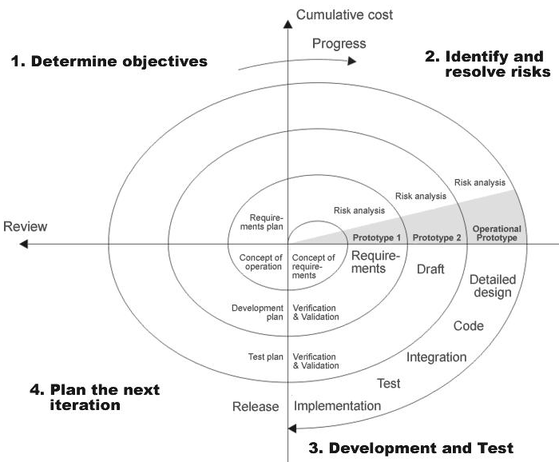

**Fig 1.0: Spiral Model**

**2.3. STUDY OF THE SYSTEM**

In the flexibility of uses the interface has been developed a graphics concepts in mind, associated through a browser interface. The GUI’s at the top level has been categorized as follows

1. Administrative User Interface Design
2. The Operational and Generic User Interface Design

The administrative user interface concentrates on the consistent information that is practically, part of the organizational activities and which needs proper authentication for the data collection. The Interface helps the administration with all the transactional states like data insertion, data deletion, and data updating along with executive data search capabilities.

The operational and generic user interface helps the users upon the system in transactions through the existing data and required services. The operational user interface also helps the ordinary users in managing their own information helps the ordinary users in managing their own information in a customized manner as per the assisted flexibilities.

# NUMBER OF MODULES:

After careful analysis the system has been identified to have the following modules:

**Admin Features:**

* Create Edit, and Delete Conference Rooms.
* Create, Edit, and Delete Users.
* Moderator Privileges.
* View and Delete Message Archives.
* View Statistics.
* Ban Users.

**Client Features:**

* User Registration
* Private Messaging
* Create Room

**Administrative Module:** This module mainly deals with creation of different users and all the updations regarding the stocks of the different manipulations and also upgrading the features of the different moderator privileges**.**

**Client Module:** This module mainly deals with the users registration,creating the private messages and it send to the admin room.Creating the room for the end users. The operational user interface also helps the ordinary users in managing their own information helps the ordinary users in managing their own information in a customized manner as per the assisted flexibilities.

**2.4. HARDWARE & SOFTWARE SPECIFICATIONS**

**Hardware Requirements:**

|  |  |  |  |
| --- | --- | --- | --- |
| **Client Side** | | | |
|  | **Processor** | **RAM** | **Disk Space** |
| **Internet Explorer 6.0**  **Or Higher** | Computer with a 2.6GHz processor or higher (Pentium processor recommended) | 512MB Minimum | Minimum 20 GB |
| **Server Side** | | | |
| **Apache Tomcat** | Intel Pentium processor at 2.6GHz or faster | Minimum 512 MB Physical Memory; 1 GB Recommended | Minimum 20 GB |
| **Net Beans 6.8**  **Oracle10g** | Intel Pentium Processor at  2.6GHz or faster | Minimum 512 MB Physical Memory; (1 GB Recommended) | Minimum 20 GB |

**Software Interface:**

* **Client on Internet/Intranet:** Any web browser.
* **Web Server:** Apache Tomcat.
* **Database Server:** Oracle10g.
* **Development End:** Net Beans 6.8

**2.5.PROBLEMS IN EXISTING SYSTEM**

The existing system is manual and the manual system works in the following way:

* Conferences will take part a vital role for any of the national wide company.
* A company like National Engineering Corporation it takes parts an important role.
* Because the company is having branches throughout India, they need to conduct Conference between their employees and to conduct board of directors meeting among their directors, general managers.

Normally conferences will be conducted in some place owned by company or in some conference hall. The person, who has to participate in the conference, has to travel all the way to participate in the conference. So it will be very risky to travel for the persons, and it is risky work for the company also to provide all the felicities to persons. Now a day wherever you see so many strikes are going. In that case to participate in any important conference or to conduct any conference will be very tedious. All this may lead to loss of company and time taking matters. So here the company is decided to develop their conferences on the net itself.

**2.6. PROPOSED SYSTEM**

To overcome all the difficulties of the existing system the management has proposed automated the whole system and the development of the new automated system contains the following activities, which try to automate the entire process keeping in view of the database integration approach.

It is to maintain the conferences, live meetings, general body meetings on the net. This system is to develop in a client/server environment. It aims to do the following.

* Grouping: Grouping of selected users
* Support of multi conference
* By selecting the single user from the list, **Talk** can be achieved.
* By selecting all the users in the list, **Chat** can be achieved.

**2.7. INPUT AND OUTPUT**

The major inputs and outputs and major functions of the system are follows:

**Inputs:**

* Admin enter his user id and password for login.
* Client can view the information.

**Outputs:**

* Admin can have his own home page.
* It will give On-line solutions from the superiors to the employees.

**Chapter 3**

**Feasibility Report**

Preliminary investigation examine project feasibility, the likelihood the system will be useful to the organization. The main objective of the feasibility study is to test the Technical, Operational and Economical feasibility for adding new modules and debugging old running system. All system is feasible if they are unlimited resources and infinite time. There are aspects in the feasibility study portion of the preliminary investigation:

* Technical Feasibility
* Operation Feasibility
* Economical Feasibility

**3.1. Technical Feasibility**

The technical issue usually raised during the feasibility stage of the investigation includes the following:

* Does the necessary technology exist to do what is suggested?
* Do the proposed equipments have the technical capacity to hold the data required to use the new system?
* Will the proposed system provide adequate response to inquiries, regardless of the number or location of users?
* Can the system be upgraded if developed?
* Are there technical guarantees of accuracy, reliability, ease of access and data security?

Earlier no system existed to cater to the needs of ‘Secure Infrastructure Implementation System’. The current system developed is technically feasible. It is a web based user interface for audit workflow at ABC Tech. Thus it provides an easy access to the users. The database’s purpose is to create, establish and maintain a workflow among various entities in order to facilitate all concerned users in their various capacities or roles. Permission to the users would be granted based on the roles specified. Therefore, it provides the technical guarantee of accuracy, reliability and security. The software and hard requirements for the development of this project are not many and are already available in-house at ABC Tech or are available as free as open source. The work for the project is done with the current equipment and existing software technology. Necessary bandwidth exists for providing a fast feedback to the users irrespective of the number of users using the system.

**3.2. Operational Feasibility**

Proposed projects are beneficial only if they can be turned out into information system. That will meet the organization’s operating requirements. Operational feasibility aspects of the project are to be taken as an important part of the project implementation. Some of the important issues raised are to test the operational feasibility of a project includes the following: -

* Is there sufficient support for the management from the users?
* Will the system be used and work properly if it is being developed and implemented?
* Will there be any resistance from the user that will undermine the possible application benefits?

This system is targeted to be in accordance with the above-mentioned issues. Beforehand, the management issues and user requirements have been taken into consideration. So there is no question of resistance from the users that can undermine the possible application benefits.

The well-planned design would ensure the optimal utilization of the computer resources and would help in the improvement of performance status.

**3.3. Economic Feasibility**

A system can be developed technically and that will be used if installed must still be a good investment for the organization. In the economical feasibility, the development cost in creating the system is evaluated against the ultimate benefit derived from the new systems. Financial benefits must equal or exceed the costs.

The system is economically feasible. It does not require any addition hardware or software. Since the interface for this system is developed using the existing resources and technologies available at ABC Tech, There is nominal expenditure and economical feasibility for certain.

**Chapter 4**

**SOFTWARE REQUIREMENT SPECIFICATION**

**INTRODUCTION**

Communication is very much essential and the importance of it is increasing from time to time along with the evolution of human needs. Developing Online meeting for an Organization.

The main concept of Online meeting is developing the conference on the net. We can compare the Online meeting with the Telephone Conference. Normally in Telephone Conference, there will be more than two users connected at a time and all the users are able to here words from any one of the user. So implementing the same concept on the Net is nothing but Online meeting.

**Scope:**

Communication is very much essential and the importance of it is increasing from time to time along with the evolution of human needs. Developing Online meeting for an Organization.

**DEVELOPERS RESPONSIBILITIES OVERVIEW:**

The developer is responsible for:

Developing the system, which meets the SRS and solving all the requirements of the system?

* Demonstrating the system and installing the system at client's location after the acceptance testing is successful.
* Submitting the required user manual describing the system interfaces to work on it and also the documents of the system.
* Conducting any user training that might be needed for using the system.
* Maintaining the system for a period of one year after installation.

## 4.1. FUNCTIONAL REQUIREMENTS:

Following is a list of functionalities of the system.

Functional Requirements means interface between the user and the hardware.

The main concept of Online meeting is developing the conference on the net. We can compare the *Online meeting* with the *Telephone Conference*. Normally in *Telephone Conference*, there will be more than two users connected at a time and all the users are able to here words from any one of the user. So implementing the same concept on the Net is nothing but *Online meeting*.

This project is used to:

* Conduct conferences with their employees. So they can get online decisions from employees from the different branches of the company.
* Another advantage is that the company is having branches throughout the country. So this will help them to communicate business affairs of the company and live meetings and conferences between their directors. They can conduct board of directors meeting.
* It will give On-line solutions from the superiors to the employees.

## 4.2. Non-Functional Requirements:

The system should be web-based system. Users should use the system via internet. Each user should have a user account. The system should ask the username and password to users. It doesn’t permit to unregistered user to access for Insurance on Internet. The system should have Role based System functions access. Approval Process has to be defined. The system should have Modular customization components so that they can be reused across the implementation.

# These are the mainly following:

* 24 X 7 availability
* Better component design to get better performance at peak time
* Flexible service based architecture will be highly desirable for future extension.

**Performance**

They understand the importance of timing, of getting there before the competition. A rich portfolio of reusable, modular frameworks helps jump-start projects. Tried and tested methodology ensures that we follow a predictable, low - risk path to achieve results. Our track record is testimony to complex projects delivered within and evens before schedule.

**Security**

Its provides more security by setting username and password.

**Safety**

This application provides more safety to the users for accessing the databases and for performing the operations on the databases.

**Interfaces**

It provides the interface for accessing the database and also allows the user to do the manipulations on the databases.

**Reliability**

This entire project is depends on the SQL Server.

**Accuracy**

Since the same table is created at different users account, the Possibility of retrieving data wrongly increases. Also if the data is more,Validations become difficult. This may result in loss of accuracy of data.

**Easy of Use**

Ever user should be comfortable of working with computer and internet browsing. He must have basic knowledge of English.

**Interoperability**

This provides the import and export facilities for sending one database to another database.

**Maintainability**

The key to reducing need for maintenance, while working, if possible to do essential tasks.

1. More accurately defining user requirement during system development.
2. Assembling better systems documentation.
3. Using more effective methods for designing, processing, login and communicating information with project team members.
4. Making better use of existing tools and techniques.
5. Managing system engineering process effectively.

**Testability:**

Testing is done in various ways such as testing the algorithm, programming code; sample data debugging is also one of following the above testing.

**4.3. PERFORMANCE REQUIREMENTS**

Performance is measured in terms of the output provided by the application.

Requirement specification plays an important part in the analysis of a system. Only when the requirement specifications are properly given, it is possible to design a system, which will fit into required environment. It rests largely in the part of the users of the existing system to give the requirement specifications because they are the people who finally use the system. This is because the requirements have to be known during the initial stages so that the system can be designed according to those requirements. It is very difficult to change the system once it has been designed and on the other hand designing a system, which does not cater to the requirements of the user, is of no use.

The requirement specification for any system can be broadly stated as given below:

* The system should be able to interface with the existing system
* The system should be accurate
* The system should be better than the existing system

The existing system is completely dependent on the user to perform all the duties.

**Chapter 5**

**SYSTEM DEVELOPEMENT ENVIRONMENT**

# 5.1. INTRODUCTION TO JAVA

**About Java**:

Initially the language was called as “oak” but it was renamed as “java” in 1995.The primary motivation of this language was the need for a platform-independent(i.e. architecture neutral)language that could be used to create software to be embedded in various consumer electronic devices.

* Java is a programmer’s language
* Java is cohesive and consistent
* Except for those constraint imposed by the Internet environment. Java gives the programmer, full control

Finally Java is to Internet Programming where c was to System Programming.

**Importance of Java to the Internet**

Java has had a profound effect on the Internet. This is because; java expands the Universe of objects that can move about freely in Cyberspace. In a network, two categories of objects are transmitted between the server and the personal computer. They are passive information and Dynamic active programs. in the areas of Security and probability. But Java addresses these concerns and by doing so, has opened the door to an exciting new form of program called the Applet.

**Applications and applets***.* An application is a program that runs on our Computer under the operating system of that computer. It is more or less like one creating using C or C++ .Java’s ability to create Applets makes it important. An Applet I san application, designed to be transmitted over the Internet and executed by a Java-compatible web browser. An applet I actually a tiny Java program, dynamically downloaded across the network, just like an image. But the difference is, it is an intelligent program, not just a media file. It can be react to the user input and dynamically change.

**Java Architecture**

Java architecture provides a portable, robust, high performing environment for development. Java provides portability by compiling the byte codes for the Java Virtual Machine, which is then interpreted on each platform by the run-time environment. Java is a dynamic system, able to load code when needed from a machine in the same room or across the planet.

# Compilation of code

## When you compile the code, the Java compiler creates machine code (called byte code)for a hypothetical machine called Java Virtual Machine(JVM). The JVM is supposed t executed the byte code. The JVM is created for the overcoming the issue of probability. The code is written and compiled for one machine and interpreted on all machines .This machine is called Java Virtual Machine.

Compiling and interpreting java source code.

**Source code**

**Pc compiler**

**Macintosh compiler**

**SPARC Compiler**

**Java Byte code**

**Platform independent**

**Java interpreter**

**Java interpretermacintosh**

**)))**

**Java interpreter(SPARC)**

During run-time the Java interpreter tricks the byte code file into thinking that it is running on a Java Virtual Machine. In reality this could be an Intel Pentium windows 95 or sun SPARCstation running Solaris or Apple Macintosh running system and all could receive code from any computer through internet and run the Applets.

**Simple**:

Java was designed to be easy for the Professional programmer to learn and to use effectively. If you are an experienced C++ Programmer. Learning Java will oriented features of C++ . Most of the confusing concepts from C++ are either left out of Java or implemented in a cleaner, more approachable manner. In Java there are a small number of clearly defined ways to accomplish a given task.

### Object oriented

Java was not designed to be source-code compatible with any other language. This allowed the Java team the freedom to design with a blank state. One outcome of this was a clean usable, pragmatic approach to objects. The object model in Java is simple and easy to extend, while simple types, such as integers, are kept as high-performance non-objects.

### Robust

The multi-platform environment of the web places extraordinary demands on a program, because the program must execute reliably in a variety of systems. The ability to create robust programs. Was given a high priority in the design of Java. Java is strictly typed language; it checks your code at compile time and runtime.

Java virtually eliminates the problems of memory management and deal location, which is completely automatic. In a well-written Java program, all run-time errors can and should be managed by your program.

**5.2. Servlets/JSP**

A Servlet Is a generic server extension. a Java class that can be loaded

Dynamically to expand the functionality of a server.Servlets are commonly used with web servers. Where they can take the place CGI scripts.

A servlet is similar to proprietary server extension, except that it runs inside a Java Virtual Machine (JVM) on the server, so it is safe and portable

Servlets operate solely within the domain of the server.

Unlike CGI and Fast CGI, which use multiple processes to handle separate program or separate requests, separate threads within web server process handle all servlets. This means that servlets are all efficient and scalable.

Servlets are portable; both across operating systems and also across web servers. Java Servlets offer the best possible platform for web application development.

Servlets are used as replacement for CGI scripts on a web server, they can extend any sort of server such as a mail server that allows servelts t extend its functionality perhaps by performing a virus scan on all attached documents or handling mail filtering tasks.

Servlets provide a Java-based solution used to address the problems currently associated with doing server-side programming including inextensible scripting solutions platform-specific API’s and incomplete interface.

Servlets are objects that conform to a specific interface that can be plugged into a Java-based server.Servlets are to the server-side what applets are to the server-side what applets are to the client-side-object byte codes that can be dynamically loaded off the net. They differ form applets in than they are faceless objects(with out graphics or a GUI component).They serve as platform independent, dynamically loadable,plugable helper byte code objects on the server side that can be used to dynamically extend server-side functionality.

For example an HTTP servlet can be used to generate dynamic HTML content when you use servlets to do dynamic content you get the following advantages:

* They’re faster and cleaner then CGI scripts
* They use a standard API( the servlet API)
* They provide all the advantages of Java (run on a variety of servers without needing to be rewritten)

**Attractiveness of servlets:**

They are many features of servlets that make them easy and attractive to tuse these include:

* Easily configure using the GUI-based Admin tool]
* Can be Loaded and Invoked from a local disk or remotely across the network.
* Can be linked together or chained, so that on servlet can call another servlet, or several servlets in sequence.
* Can be called dynamically from with in HTML, pages using server-side include-tags.
* Are secure-even when downloading across the network, the servlet security model and servlet and box protect your system from unfriendly behavior.,

**Advantages of the servlet API**

One of the great advantages of the servlet API is protocol independent. It assumes nothing about:

* The protocol being used to transmit on the net
* How it is loaded
* The server environment it will be running in
* These quantities are important, because it allows the Servlet API to be embedded in many different kinds of servers.There are other advantages to the servelt API as well These include:
* It’s extensible-you can inherit all your functionality from the base classes made available to you
* It’s simple small, and easy to use.

**Features of Servlets:**

* Servlets are persistent.Servlet are loaded only by the web server and can maintain services between requests.
* Servlets are fast. Since servlets only need to be l\loaded once, they offer much better performance over their CGI counterparts.
* Servlets are platform independent.
* Servlets are extensible Java is a robust, object-oriented programming language, which easily can be extended to suit your needs.
* Servlets are secure
* Servlets are used with a variety of client.

Servlets are classes and interfaces from tow packages,javax .servlet and javax.servlet.http.The java.servlet package contains classes t support generic, protocol-independent servlets.The classes in the javax.servelt.http package To and HTTP specific functionality extend these classes

Every servlet must implement the javax.servelt interface.Most servlets implement it by extending one of two classes.javax.servlet.GenericServlet or javax.servlet.http.HttpServlet.A protocol-independent servlet should subclass Generic-Servlet.while an Http servlet should subclass HttpServlet, which is itself a subclass of Generic-servlet with added HTTP-specific functionality.

Unlike a java program, a servlet does not have a main() method,Instead the server in the process of handling requests invoke certain methods of a servlet.Each time the server dispatches a request to a servlet, it invokes the servelts Service() method,

A generic servlet should override its service() method to handle requests as appropriate for the servlet.The service() accepts two parameters a request object and a response object .The request object tells the servlet about the request, while the response object is used to return a response

InContrast.anHttp servlet usually does not override the service() method.Instead it overrides doGet() to handle GET requests and doPost() to handle Post requests. An Http servlet can override either or both of these modules the service() method of HttpServlet handles the setup and dispatching to all the doXXX() methods.which iswhy it usually should not be overridden

The remainders in the javax.servlet and javax.servlet.http.package are largely support classes .The ServletRequest and ServletResponse classes in javax.servlet provide access to generic server requests and responses while HttpServletRequest and HttpServletResponse classes in javax.servlet provide access to generic server requests and responses while HttpServletRequest and HttpServletResponse in javax.servlet.http provide access a HTTP requests and responses . The javax.servlet.http provide contains an HttpSession class that provides built-in session tracking functionality and Cookie class that allows quickly setup and processing HttpCookies.

**Loading Servlets:**

Servlets can be loaded from their places. From a directory that is on the CLASSPATH. The CLASSPATH of the JavaWebServer includes service root/classes/, which is where the system classes reside

From the <SERVICE_ROOT/servlets/directory.This is not in the server’s classpath. A class loader is used to create servlets form this directory.New servlets can be added-existing servlets can be recompiled and the server will notice these changes. From a remote location.For this a code base like <http://nine.eng/classes/foo/> is required in addtion to the servlet’s class name.Refer to the admin Gui docs on servlet section to see how to set this up.

Loading Remote Servlets

Remote servlets can be loaded by:

* Configuring the admin Tool to setup automatic loading of remote servlets.
* Selectiong up server side include tags in .html files
* Defining a filter chain Configuration

**Invoking Servlets**

A servlet invoker is a servlet that invokes the “server” method on a named servlet.If the servlet is not loaded in the server,then the invoker first loades the servlet(either form local disk or from the network) and the then invokes the “service” method.Also like applets,local servlets in the server can be identified by just the class name.In other words, if a servlet name is not absolute.it is treated as local.

A Client can Invoke Servlets in the Following Ways:

* The client can ask for a document that is served by the servlet.
* The client(browser) can invoke the servlet directly using a URL, once it has been mapped using the SERVLET ALIASES Section of the admin GUI
* The servlet can be invoked through server side include tags.
* The servlet can be invoked by placing it in the servlets/directory
* The servlet can be invoked by using it in a filter chain

**The Servlet Life Cycle:-**

The Servlet life cycle is one of the most exciting features of Servlets.This life cycle is a powerful hybrid of the life cycles used in CGI programming and lower-level NSAPI and ISAPI programming.

The servlet life cycle allows servlet engines to address both the performance and resource problems of CGI and the security concents of low level server API programming.

Servlet life cycle is highly flexible Servers hava significant leeway in how they choose to support servlets.The only hard and fast rule is that a servlet engine must confor to the following life cycle contact:

* Create and initialize the servlets
* Handle zero or more service from clients
* Destroy the servlet and then garbage Collects it.

It’s perfectly legal for a servlet t be loaded, created an initialzed in its own JVM,only to be destroyed an dgarbage collected without hancdling any clientrequest or after handling just one request

The most common and most sensible life cycle implemntations for HTTP servelts are:

Single java virtual machine and astatine persistence.

**Init and Destroy**:-

Just like Applets servlets can define init() and destroy() methods, A servlets init(ServiceConfig) method is called by the server immediately after the server constructs the servlet’s instance.Depanding on the server and its configuration, this can be at any of these times

* When the server states
* When the servlet is first requested, just before the service() method is invoked
* At the request of the server administrator

In any case, nit() is guaranteed to be called before the servlet handles its first request

The init() method is typically used to perform servlet initialization creating or loading objects that are used by the servlet in handling of its request. In order to providing a new servlet any information about itself and its environment, a server has to call a servelts init() method and pass an object that implement the ServletConfig interface.

This ServletConfig object supplies a servlet with information about its initialization parameters.These parameters are given to the servlets and are not associated with any single request.They can specify initial values, such as where a counter should begin counting, or default values, perhaps a template to use when not specified by the request,

The server calls a servlet’s destroy() method when the servlet is about to be unloaded. In the destroy() method, a servlet should free any resources it has acquired that will not be garbage collected. The destroy() method also gives a servlet a chance to write out its unsaved. cached information or any persistent information that should be read during the next call to init().

**Session Tracking:**

HTTP is a stateless protocol, it provides no way for a server to recognize that a sequence of requests is all from the same client. This causes a problem for application such as shopping cart applications. Even in chat application server can’t know exactly who’s making a request of several clients.

The solution for this is for client to introduce itself as it makes each request, Each clients needs to provide a unique identifier that lets the server identify it, or it needs to give some information that the server can use to properly handle the request, There are several ways to send this introductory information with each request Such as:

**USER AUTHORIZATION:**

One way to perform session tracking is to leverage the information that comes with

User authorization. When a web server restricts access to some of its resources to only those clients that log in using a recognized username and password. After the client logs in, the username is available to a servlet through getRemoteUser()

Wean use the username to track the session. Once a user has logged in, the browser remembers her username and resends the name and password as the user views new pages on the site. A servlet can identify the user through her username and they’re by

Track her session.

The biggest advantage of using user authorization to perform session tracking is that it’s easy to implement. Simply tell the protect a set of pages, and use getRemoteUser() to identify each client.Another advantage is that the technique works even when the user accesses your site form or exists her browser before coming back.

The biggest disadvantage of user authrization is that it requires each user to register for an account and then log in in each time the starts visiting your site. Most users will tolerate registering and lagging in as a necessary evil when they are accessing sensitive information, but its all overkill for simple session tracking.Other problem with user authorization is that a user cannot simultaneously maintain more than one session at the same site.

**Hidden Form Fields:**

One way to support anonymous session tracking is to use hidden from fields. As the name implies, these are fields added to an HTML, form that are not displayed in the client’s browser, They are sent back to the server when the form that contains them is submitted.

In a sense, hidden form fields define constant variables for a form. To a servlet receiving a submitted form, there is no difference between a hidden fields and a visible filed.

As more and more information is associated with a clients session . It can become burdensome to pass it all using hidden form fields. In these situations it’s possible to pass on just a unique session ID that identifies as particular clients session.

That session ID can be associated with complete information about its session that is stored on the server.

The advantage of hidden form fields is their ubiquity and support for anonymity. Hidden fields are supported in all the popular browsers, they demand on special server requirements, and they can be used with clients that haven’t registered or logged in.

The major disadvantage with this technique, however is that works only for a sequence of dynamically generated forms, The technique breaks down immediately with static documents, emailed documents book marked documents and browser shutdowns.

**URL Rewriting:**

URL rewriting is another way to support anonymous session tracking, With URL rewriting every local URL the user might click on is dynamically modified. or rewritten, to include extra, information. The extra information can be in the deform of extra path information, added parameters, or some custom, server-specific.URL change. Due to the limited space available in rewriting a URL, the extra information is usually limited to a unique session.

Each rewriting technique has its own advantage and disadvantage

Using extra path information works on all servers, and it works as a target for forms that use both the Get and Post methods. It does not work well if the servlet has to use the extra path information as true path information

The advantages and disadvantages of URL.rewriting closely match those of hidden form fileds,The major difference is that URL rewriting works for all dynamically created documents, such as the Help servlet, not just forms. With the right server support, custom URL rewriting can even work for static documents.

**Persistent Cookies:**

A fourth technique to perform session tracking involves persistent cookies. A cookie is a bit of information. sent by a web server to a browser that can later be read back form that browser. When a browser receives a cookie, it saves the cookie and there after sends the cookie back to the server each time it accesses a page on that server, subject to certain rules. Because a cookie’s value can uniquely identify a client, cookies are often used for session tracking.

Persistent cookies offer an elegant, efficient easy way to implement session tracking. Cookies provide as automatic an introduction for each request as we could hope for. For each request, a cookie can automatically provide a client’s session ID or perhaps a list of clients performance. The ability to customize cookies gives them extra power and versatility.

The biggest problem with cookies is that browsers don’t always accept cookies sometimes this is because the browser doesn’t support cookies. More often its because

The browser doesn’t support cookies. More often its because the user has specifically configured the browser to refuse cookies.

The power of serves:

The power of servlets is nothing but the advantages of servlets over other approaches, which include portability, power, efficiency, endurance, safety elegance,integration,extensibility and flexibility.

**Portability:**

As servlets are written in java and conform to a well defined and widely accepted API.they are highly portable across operating systems and across server implementation

We can develop a servlet on a windows NT machine running the java web server and later deploy it effortlessly on a high-end Unix server running apache. With servlets we can really “write once, serve every where”

Servlet portability is not the stumbling block it so often is with applets, for two reasons

First,Servlet portability is not mandatory i.e. servlets has to work only on server machines that we are using for development and deployment

Second, servlets avoid the most error-prone and inconstancy implemented portion of the java languages.

**Power:**

Servlets can harness the full power of the core java. API’s: such as Networking and Url access, multithreading, image manipulation, data compression, data base connectivity, internationalization, remote method invocation(RMI) CORBA connectivity, and object serialization, among others,

**Efficiency And Endurance:**

Servlet invocation is highly efficient, Once a servlet is loaded it generally remains in the server’s memory as a single object instance, There after the server invokes the servelt to handle a request using a simple, light weighted method invocation .Unlike the CGI, there’s no process to spawn or interpreter to invoke, so the servlet can begin handling the request almost immediately, Multiple, concurrent requests are handled the request almost immediately. Multiple, concurrent requests are handled by separate threads, so servlets are highly scalable.

Servlets in general are enduring objects. Because a servlets stays in the server’s memory as a single object instance. it automatically maintains its state and can hold onto external resources, such as database connection

**Safety:**

Servlets support safe programming practices on a number of levels.

As they are written in java,servlets inherit the strong type safety of the java language. In addition the servlet API is implemented to be type safe. Java’s automatic garbage collection and lack of pointers mean that servlets are generally safe from memory management problems like dangling pointers invalid pointer references and memory leaks.

Servlets can handle errors safely, due to java’s exception – handling mechanism. If a servlet divides by zero or performs some illegal operations, it throws an exception that can be safely caught and handled by the server.

A server can further protect itself from servlets through the use of java security manager.A server can execute its servlets under the watch of a strict security manager.

**Elegance:**

The elegance of the servlet code is striking .Servlet code is clean, object oriented modular and amazingly simple one reason for this simplicity is the served API itself. Which includes methods and classes to handle many of the routine chores of servlet development. Even advanced to operations like cookie handling and session tracking tracking are abstracted int convenient classes.

**Integration:**

Servlets are tightly integrated with the server. This integration allows a servlet to cooperate with the server in two ways . for e.g.: a servlet can use the server to translate file paths, perform logging, check authorization, perform MIME type mapping and in some cases even add users to the server’s user database.

**Extensibility and Flexibility:**

The servlet API is designed to be easily extensible. As it stands today the API includes classes that are optimized for HTTP servlets.But later it can be extended and optimized for another type of servlets.It is also possible that its support for HTTP servlets could be further enhanced.

Servlets are also quite flexible, Sun also introduced java server pages. which offer a way to write snippets of servlet code directly with in a static HTML page using syntax similar to Microsoft’s Active server pages(ASP)

**5.3. JDBC**

**What is JDBC?**

any relational database. One can write a single program using the JDBC API,and the JDBC is a Java Api for executing SQL,Statements(As a point of interest JDBC is trademarked name and is not an acronym; nevertheless,Jdbc is often thought of as standing for Java Database Connectivity. It consists of a set of classes and interfaces written in the Java Programming language.JDBC provides a standard API for tool/database developers and makes it possible to write database applications using a pure Java API

Using JDBC, it is easy to send SQL statements to virtually program will be able to send SQL .statements to the appropriate database. The Combination of Java and JDBC lets a programmer writes it once and run it anywhere.

***What Does JDBC Do?***

**Simply put,JDBC makes it possible to do three things**

* Establish a connection with a database
* Send SQL statements
* Process the results
* JDBC Driver Types
* The JDBC drivers that we are aware of this time fit into one of four categories
* JDBC-ODBC Bridge plus ODBC driver
* Native-API party-java driver
* JDBC-Net pure java driver
* Native-protocol pure Java driver

An individual database system is accessed via a specific JDBC driver that implements the java.sql.Driver interface. Drivers exist for nearly all-popular RDBMS systems, through few are available for free. Sun bundles a free JDBC-ODBC bridge driver with the JDK to allow access to a standard ODBC,data sources, such as a Microsoft Access database, Sun advises against using the bridge driver for anything other than development and very limited development.

JDBC drivers are available for most database platforms, from a number of vendors and in a number of different flavours. There are four driver categories

**Type 01-JDBC-ODBC Bridge Driver**

Type 01 drivers use a bridge technology to connect a java client to an ODBC database service. Sun’s JDBC-ODBC bridge is the most common type 01 driver. These drivers implemented using native code.

**Type 02-Native-API party-java Driver**

Type 02 drivers wrap a thin layer of java around database-specific native code libraries for Oracle databases, the native code libraries might be based on the OCI(Oracle call Interface) libraries, which were originally designed for **c/c++** programmers, Because type-02 drivers are implemented using native code. in some cases they have better performance than their all-java counter parts. They add an element of risk, however, because a defect in a driver’s native code section can crash the entire server

**Type 03-Net-Protocol All-Java Driver**

Type 03 drivers communicate via a generic network protocol to a piece of custom middleware. The middleware component might use any type of driver to provide the actual database access. These drivers are all java, which makes them useful for applet deployment and safe for servlet deployment

**Type-04-native-protocol All-java Driver**

Type o4 drivers are the most direct of the lot. Written entirely in java, Type 04 drivers understand database-specific networking. protocols and can access the database directly without any additional software

**JDBC-ODBC Bridge**

If possible use a Pure Java JDBC driver instead of the Bridge and an ODBC driver. This completely eliminates the client configuration required by ODBC.It also eliminates the potential that the Java VM could be corrupted by an error in the native code brought in by the Bridge(that is, the Bridge native library, the ODBC driver manager library, library, the ODBC driver library, and the database client library)

**WHAT IS The JDBC-ODBE Bridge ?**

The JDBC-ODBC Bridge is a Jdbc driver, which implements JDBC operations by translating them into ODBC operations. To ODBC it appears as a normal application program. The Bridge is implemented as the sun.jdbc.odbc Java package and contains a native library used to access ODBC.The Bridge is joint development of Intersolv and Java Soft

**5.4. HTML, JAVASCRIPT**

Hypertext Markup Language(HTML), the languages of the world wide web(WWW), allows users to produces web pages that included text, graphics and pointer to other web pages (Hyperlinks).

HTML is not a programming language but it is an application of ISO Standard 8879,SGML(Standard Generalized Markup Language),but

Specialized to hypertext and adapted to the Web. The idea behind Hypertext one point to another point. We can navigate through the information based on out interest and preference. A markup language is simply a series of items enclosed within the elements should be displayed.

Hyperlinks are underlined or emphasized works that load to other documents or some portions of the same document.

Html can be used to display any type of document on the host computer, which can be geographically at a different location. It is a versatile language and can be used on any platform or desktop

HTML provides tags(special codes) to make the document look attractive.

HTML provides are not case-sensitive. Using graphics,fonts,different sizes, color, etc.. can enhance the presentation of the document. Anything

That is not a tag is part of the document it self.

**Basic Html Tags**:

<!-- --> Specific Comments.

<A>………</A> Creates Hypertext links.

<B>………</B> Creates hypertext links.

<Big>……..</Big> Formats text in large-font

<Body>…….</Body> contains all tags and text in the Html-document

<Center>……</Center> Creates Text

<DD>………..</DD> Definition of a term.

<TABLE>……</TABLE> creates table

<Td>………..</Td> indicates table data in a table.

<Tr>………..</Tr> designates a table row

<Th>……….</Th> creates a heading in a table.

##### *A D V A N T A G E S:-*

* + A HTML document is small and hence easy to send over the net.It is small because it does not include formatted information.
  + HTML is platform independent

HTML tags are not case-sensitive.

**JAVA SCRIPT**

The Java Script Language

JavaScript is a compact , object-based scripting language for developing client and server internet applications. Netscape Navigator 2.0 interprets JavaScript statements embedded directly in an HTML page. and Livewire enables you to create server-based applications similar to common gateway interface(cgi) programs.

In a client application for Navigator, JavaScript statements embedded in an HTML Page can recognize and respond to user events such as mouse clicks form

Input, and page navigation.

For example, you can write a JavaScript function to verify that users enter valid information into a form requesting a telephone number or zip code . Without any network transmission, an Html page with embedded Java Script can interpret the entered text and alert the user with a message dialog if the input is invalid or you can use JavaScript to perform an action (such as play an audio file, execute an applet, or communicate with a plug-in) in response to the user opening or exiting a page.

**5.5. ORACLE**

Oracle is a relational database management system, which organizes data in the form of tables. Oracle is one of many database servers based on RDBMS model, which manages a seer of data that attends three specific things-data structures, data integrity and data manipulation.

With oracle cooperative server technology we can realize the benefits of open, relational systems for all the applications. Oracle makes efficient use of all systems resources, on all hardware architecture; to deliver unmatched performance, price performance and scalability. Any DBMS to be called as RDBMS has to satisfy Dr.E.F.Codd’s rules.

**Features of Oracle:**

**Portable**

The Oracle RDBMS is available on wide range of platforms ranging from PCs to super computers and as a multi user loadable module for Novel NetWare, if you develop application on system you can run the same application on other systems without any modifications.

**Compatible**

Oracle commands can be used for communicating with IBM DB2 mainframe RDBMS that is different from Oracle, which is Oracle compatible with DB2. Oracle RDBMS is a high performance fault tolerant DBMS, which is specially designed for online transaction processing and for handling large database applications.

**Multithreaded Server Architecture**

Oracle adaptable multithreaded server architecture delivers scalable high performance for very large number of users on all hardware architecture including symmetric multiprocessors (sumps) and loosely coupled multiprocessors. Performance is achieved by eliminating CPU, I/O, memory and operating system bottlenecks and by optimizing the Oracle DBMS server code to eliminate all internal bottlenecks.

Oracle has become the most popular RDBMS in the market because of its ease of use

* Client/server architecture.
* Data independence.
* Ensuring data integrity and data security.
* Managing data concurrency.
* Parallel processing support for speed up data entry and online transaction processing used for applications.
* DB procedures, functions and packages.

**Dr.E.F.Codd’s Rules**

These rules are used for valuating a product to be called as relational database management systems. Out of 12 rules, a RDBMS product should satisfy at least 8 rules + rule called rule 0 that must be satisfied.

**RULE 0: Foundation Rule**

For any system to be advertised as, or claimed to be relational DBMS should manage database with in it self, with out using an external language.

**RULE 1: Information Rule**

All information in relational database is represented at logical level in only one way as values in tables.

**RULE 2: Guaranteed Access**

Each and every data in a relational database is guaranteed to be logically accessibility by using to a combination of table name, primary key value and column name.

**RULE 3: Systematic Treatment of Null Values**

Null values are supported for representing missing information and inapplicable information. They must be handled in systematic way, independent of data types.

**RULE 4: Dynamic Online Catalog based Relation Model**

The database description is represented at the logical level in the same way as ordinary data so that authorized users can apply the same relational language to its interrogation as they do to the regular data.

**RULE 5: Comprehensive Data Sub Language**

A relational system may support several languages and various models of terminal use. However there must be one language whose statement can express all of the following:

Data Definitions, View Definitions, Data Manipulations, Integrity, Constraints, Authorization and transaction boundaries.

**RULE 6: View Updating**

Any view that is theoretical can be updatable if changes can be made to the tables that effect the desired changes in the view.

**RULE 7: High level Update, Insert and Delete**

The capability of handling a base relational or derived relational as a single operand applies not only retrieval of data also to its insertion, updating, and deletion.

**RULE 8: Physical Data Independence**

Application program and terminal activities remain logically unimpaired whenever any changes are made in either storage representation or access method.

**RULE 9: Logical Data Independence**

Application programs and terminal activities remain logically unimpaired whenever any changes are made in either storage representation or access methods.

**RULE 10: Integrity Independence**

Integrity constraints specific to particular database must be definable in the relational data stored in the catalog, not in application program.

**RULE 11: Distributed Independence**

Whether or not a system supports database distribution, it must have a data sub-language that can support distributed databases without changing the application program.

**RULE 12: Non Sub-Version**

If a relational system has low level language, that low language cannot use to subversion or by pass the integrity rules and constraints expressed in the higher level relational language.

**Oracle supports the following Codd’s Rules**

Rule 1: Information Rule (Representation of information)-YES.

Rule 2: Guaranteed Access-YES.

Rule 3: Systematic treatment of Null values-YES.

Rule 4: Dynamic on-line catalog-based Relational Model-YES.

Rule 5: Comprehensive data sub language-YES.

Rule 6: View Updating-PARTIAL.

Rule 7: High-level Update, Insert and Delete-YES.

Rule 8: Physical data Independence-PARTIAL.

Rule 9: Logical data Independence-PARTIAL.

Rule 10: Integrity Independence-PARTIAL.

Rule 11: Distributed Independence-YES.

Rule 12: Non-subversion-YES.

**Chapter 6**

**SYSTEM DESIGN**

**6.1. INTRODUCTION**

Software design sits at the technical kernel of the software engineering process and is applied regardless of the development paradigm and area of application. Design is the first step in the development phase for any engineered product or system. The designer’s goal is to produce a model or representation of an entity that will later be built. Beginning, once system requirement have been specified and analyzed, system design is the first of the three technical activities -design, code and test that is required to build and verify software.

The importance can be stated with a single word “Quality”. Design is the place where quality is fostered in software development. Design provides us with representations of software that can assess for quality. Design is the only way that we can accurately translate a customer’s view into a finished software product or system. Software design serves as a foundation for all the software engineering steps that follow. Without a strong design we risk building an unstable system – one that will be difficult to test, one whose quality cannot be assessed until the last stage.

During design, progressive refinement of data structure, program structure, and procedural details are developed reviewed and documented. System design can be viewed from either technical or project management perspective. From the technical point of view, design is comprised of four activities – architectural design, data structure design, interface design and procedural design.

**6.2. NORMALIZATION**

It is a process of converting a relation to a standard form. The process is used to handle the problems that can arise due to data redundancy i.e. repetition of data in the database, maintain data integrity as well as handling problems that can arise due to insertion, updation, deletion anomalies.

Decomposing is the process of splitting relations into multiple relations to eliminate anomalies and maintain anomalies and maintain data integrity. To do this we use normal forms or rules for structuring relation.

**Insertion anomaly**: Inability to add data to the database due to absence of other data.

**Deletion anomaly**: Unintended loss of data due to deletion of other data.

**Update anomaly**: Data inconsistency resulting from data redundancy and partial update

**Normal Forms**: These are the rules for structuring relations that eliminate anomalies.

**FIRST NORMAL FORM**:

A relation is said to be in first normal form if the values in the relation are atomic for every attribute in the relation. By this we mean simply that no attribute value can be a set of values or, as it is sometimes expressed, a repeating group.

**SECOND NORMAL FORM**:

A relation is said to be in second Normal form is it is in first normal form and it should satisfy any one of the following rules.

1. Primary key is a not a composite primary key
2. No non key attributes are present
3. Every non key attribute is fully functionally dependent on full set of primary key.

**THIRD NORMAL FORM**:

A relation is said to be in third normal form if their exits no transitive dependencies.

**Transitive Dependency**: If two non key attributes depend on each other as well as on the primary key then they are said to be transitively dependent.

The above normalization principles were applied to decompose the data in multiple tables thereby making the data to be maintained in a consistent state.

**6.3. DATA DICTIONARY**

**Database Tables (Data Dictionary):** After careful analysis the system has identified to be presented with the following database tables:

**empdetails**

Name Null? Type

----------------------------------------------------- -------- ----------------

EMPID NUMBER

KEY VARCHAR2(10)

AC_STATUS VARCHAR2(1)

DOJ VARCHAR2(10)

USERID VARCHAR2(25)

**address book**

Name Null? Type

----------------------------------------------------- -------- ----------------

NAME VARCHAR2(40)

USERID VARCHAR2(20)

DOB VARCHAR2(14)

EMAIL VARCHAR2(40)

PHONE VARCHAR2(16)

CITY VARCHAR2(30)

OUSERID VARCHAR2(25)

**advices**

Name Null? Type

----------------------------------------------------- -------- ----------------

NAME VARCHAR2(50)

PHONE VARCHAR2(14)

EMPID VARCHAR2(6)

ADDRESS VARCHAR2(40)

MESSAGE VARCHAR2(500)

**clientonline**

Name Null? Type

----------------------------------------------------- -------- ----------------

USERID VARCHAR2(25)

ROOMNAME VARCHAR2(20)

DATEOFLOG VARCHAR2(25)

TIMEOFLOG VARCHAR2(25)

**mail**

Name Null? Type

----------------------------------------------------- -------- ----------------

USERID VARCHAR2(25)

WHOSEND VARCHAR2(25)

MESSAGE LONG

TIMING VARCHAR2(50)

READ CHAR(1)

SUBJECT VARCHAR2(25)

**password**

Name Null? Type

----------------------------------------------------- -------- ----------------

USERID VARCHAR2(25)

PWD VARCHAR2(20)

BAN VARCHAR2(1)

**roomdetails**

Name Null? Type

----------------------------------------------------- -------- ----------------

ROOMNAME VARCHAR2(25)

RIN VARCHAR2(20)

MODERATOR VARCHAR2(25)

**userdetails**

Name Null? Type

----------------------------------------------------- -------- ----------------

USERID VARCHAR2(25)

NAME VARCHAR2(60)

ADDRESS VARCHAR2(120)

ZIP VARCHAR2(6)

PHONE VARCHAR2(12)

EMAIL VARCHAR2(50)

SEX VARCHAR2(1)

EDUCATION VARCHAR2(30)

COUNTRY VARCHAR2(25)

CITY VARCHAR2(20)

STATE VARCHAR2(25)

DOB VARCHAR2(12)

**security**

Name Null? Type

----------------------------------------------------- -------- ----------------

USERID VARCHAR2(25)

QUES VARCHAR2(100)

ANS VARCHAR2(50)

**6.4. E – R DIAGRAMS**

* + The relation upon the system is structure through a conceptual ER-Diagram, which not only specifics the existential entities but also the standard relations through which the system exists and the cardinalities that are necessary for the system state to continue.
  + The Entity Relationship Diagram (ERD) depicts the relationship between the data objects. The ERD is the notation that is used to conduct the date modeling activity the attributes of each data object noted is the ERD can be described resign a data object descriptions.
  + The set of primary components that are identified by the ERD are
  + Data object
  + Relationships
  + Attributes
  + Various types of indicators.

The primary purpose of the ERD is to represent data objects and their relationships.

**ER-Diagrams:**

**ADMINISTRATOR:**

**ADMINISTRATOR**

**CLIENT**

**CLIENT:**

**6.5. DATA FLOW DIAGRAMS**

A data flow diagram is graphical tool used to describe and analyze movement of data through a system. These are the central tool and the basis from which the other components are developed. The transformation of data from input to output, through processed, may be described logically and independently of physical components associated with the system. These are known as the logical data flow diagrams. The physical data flow diagrams show the actual implements and movement of data between people, departments and workstations. A full description of a system actually consists of a set of data flow diagrams. Using two familiar notations Yourdon, Gane and Sarson notation develops the data flow diagrams. Each component in a DFD is labeled with a descriptive name. Process is further identified with a number that will be used for identification purpose. The development of DFD’S is done in several levels. Each process in lower level diagrams can be broken down into a more detailed DFD in the next level. The lop-level diagram is often called context diagram. It consist a single process bit, which plays vital role in studying the current system. The process in the context level diagram is exploded into other process at the first level DFD.

The idea behind the explosion of a process into more process is that understanding at one level of detail is exploded into greater detail at the next level. This is done until further explosion is necessary and an adequate amount of detail is described for analyst to understand the process.

Larry Constantine first developed the DFD as a way of expressing system requirements in a graphical from, this lead to the modular design.

A DFD is also known as a “bubble Chart” has the purpose of clarifying system requirements and identifying major transformations that will become programs in system design. So it is the starting point of the design to the lowest level of detail. A DFD consists of a series of bubbles joined by data flows in the system.

**DFD SYMBOLS:**

In the DFD, there are four symbols

1. A square defines a source(originator) or destination of system data
2. An arrow identifies data flow. It is the pipeline through which the information flows
3. A circle or a bubble represents a process that transforms incoming data flow into outgoing data flows.
4. An open rectangle is a data store, data at rest or a temporary repository of data

Process that transforms data flow

Source or Destination of data

Data flow

Data Store

**CONSTRUCTING A DFD:**

Several rules of thumb are used in drawing DFD’S:

1. Process should be named and numbered for an easy reference. Each name should be representative of the process.
2. The direction of flow is from top to bottom and from left to right. Data traditionally flow from source to the destination although they may flow back to the source. One way to indicate this is to draw long flow line back to a source. An alternative way is to repeat the source symbol as a destination. Since it is used more than once in the DFD it is marked with a short diagonal.
3. When a process is exploded into lower level details, they are numbered.
4. The names of data stores and destinations are written in capital letters. Process and dataflow names have the first letter of each work capitalized

A DFD typically shows the minimum contents of data store. Each data store should contain all the data elements that flow in and out.

Questionnaires should contain all the data elements that flow in and out. Missing interfaces redundancies and like is then accounted for often through interviews.

**SAILENT FEATURES OF DFD’S**

1. The DFD shows flow of data, not of control loops and decision are controlled considerations do not appear on a DFD.
2. The DFD does not indicate the time factor involved in any process whether the dataflow take place daily, weekly, monthly or yearly.
3. The sequence of events is not brought out on the DFD.

**TYPES OF DATA FLOW DIAGRAMS**

1. Current Physical
2. Current Logical
3. New Logical
4. New Physical

**CURRENT PHYSICAL:**

In Current Physical DFD process label include the name of people or their positions or the names of computer systems that might provide some of the overall system-processing label includes an identification of the technology used to process the data. Similarly data flows and data stores are often labels with the names of the actual physical media on which data are stored such as file folders, computer files, business forms or computer tapes.

**CURRENT LOGICAL:**

The physical aspects at the system are removed as much as possible so that the current system is reduced to its essence to the data and the processors that transform them regardless of actual physical form.

**NEW LOGICAL**:

This is exactly like a current logical model if the user were completely happy with the user were completely happy with the functionality of the current system but had problems with how it was implemented typically through the new logical model will differ from current logical model while having additional functions, absolute function removal and inefficient flows recognized.

**NEW PHYSICAL:**

The new physical represents only the physical implementation of the new system.

**RULES GOVERNING THE DFD’S**

**PROCESS**

1. No process can have only outputs.
2. No process can have only inputs. If an object has only inputs than it must be a sink.
3. A process has a verb phrase label.

**DATA STORE**

1. Data cannot move directly from one data store to another data store, a process must move data.
2. Data cannot move directly from an outside source to a data store, a process, which receives, must move data from the source and place the data into data store
3. A data store has a noun phrase label.

**SOURCE OR SINK**

The origin and /or destination of data

1. Data cannot move direly from a source to sink it must be moved by a process
2. A source and /or sink has a noun phrase land

**DATA FLOW**

1. A Data Flow has only one direction of flow between symbols. It may flow in both directions between a process and a data store to show a read before an update. The later is usually indicated however by two separate arrows since these happen at different type.
2. A join in DFD means that exactly the same data comes from any of two or more different processes data store or sink to a common location.
3. A data flow cannot go directly back to the same process it leads. There must be at least one other process that handles the data flow produce some other data flow returns the original data into the beginning process.
4. A Data flow to a data store means update (delete or change).
5. A data Flow from a data store means retrieve or use.

A data flow has a noun phrase label more than one data flow noun phrase can appear on a single arrow as long as all of the flows on the same arrow move together as one package

Architectural View of Online meeting Media:

Admin

Client

Client

Moderator

I Level DFD for Admin

Admin

Login Information

Verify Admin ID, Password

Return Message

I Level DFD for Client

Client

Login Information

Verify UserID

Password

Return Message

Storing Info

Invalid User

Valid User

II Level DFD for Client

Client

Password

Password

User Details

Invalid User

Userid

User Info

UserId&Pwd

Security

Hint Q&A

Valid User

Client Online

Room

Name

Room Details

Offline

Room Creation

Save Offline

Logout

Room table

Client online

Room table

Save online messages

Client

Password

User details

Addresses

II Level DFD for Admin

Admin

Password

Password

Userid

Password

Emp Details

Sitemap:

**MAIN**

**ADMIN**

**SITEMAP**

**SITEMAP**

**SITEMAP**

**SITEMAP**

**SUGGESTIONS**

**CLIENT**

**SUGGESTIONS**

**HELP**

**Change Password**

**Contacts**

**Conference**

**Statistics**

**Offline**

**Contacts**

**User**

**Maintenance**

**Contacts**

**Conference**

**Offline**

**Change Password**

**View Profiles of Others**

**Check User Status**

**Search Contact**

**View Profiles of Others**

**Add Employee**

**Check suggestions**

**6.6. ACTIVITY DIAGRAMS**

Admin Login

Verify Registration

Add Products

View Products

Search Products

Verify Requests

**6.7. USE CASE DIAGRAMS**

Administrator Use Case Diagram

ADMINISTRATOR

Create

Room

Add Client

Delete Client

Conference

CLIENT

MODERATOR

Or CLIENT

Login Verification

<<Extends>>

Password Verification

p

**6.8. SEQUENCE DIAGRAMS**

Administrator Sequence Diagram

Admin

Login

Add Employee

Check Sugge

stions

User Maintenance

Ener Id,Password

Verify

Succses

Add Employee Details

Succses

Check Suggestions

Succses

User Maintenance

Succses

Ban user

Delete

user

**6.9. CLASS DIAGRAMS**

DataManipulator

Login

InputScreen

Report

Menu

GUIComponent

Add Employee

DataStore

options

conference

Check Suggestion

Search

View status

<<instantiates>>

<<uses>>

Options

user maintence

**State Diagram:**

**( id,pwd )**

**authenticated**

Adminr Menu

**Validation**

unauthenticated

**( valid )**

**( invalid )**

**( username,pwd)**

Adminr Menu

**Validation**

unauthenticated

**( valid )**

**( invalid )**

**( username,pwd)**

**Chapter 7**

**OUTPUT SCREENS**

**Form Design:**

Here are the following form designs for Online meeting Media:

After careful analysis the system has identified to be presented with the following form design:

**Home Page:**

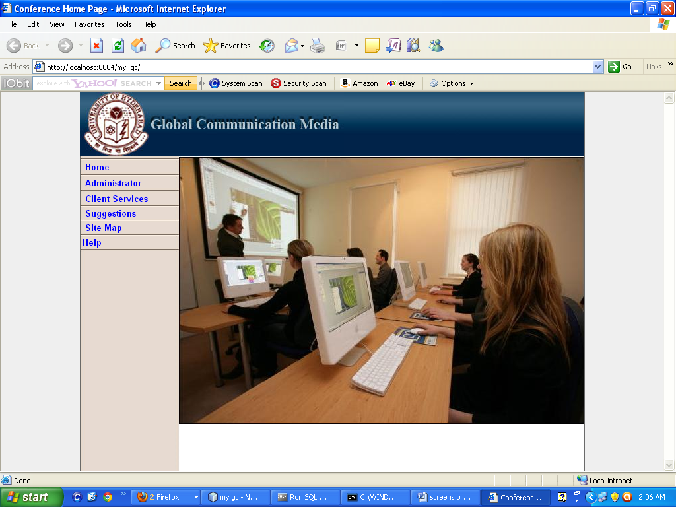

ADMIN LOGIN PAGE

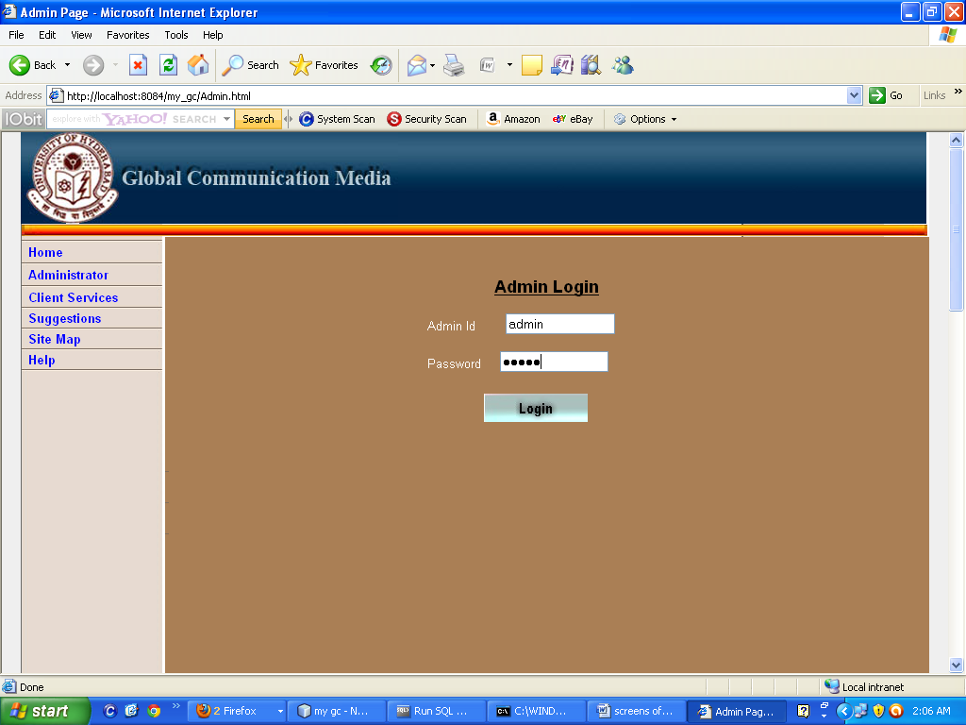

ADMIN HOME PAGE

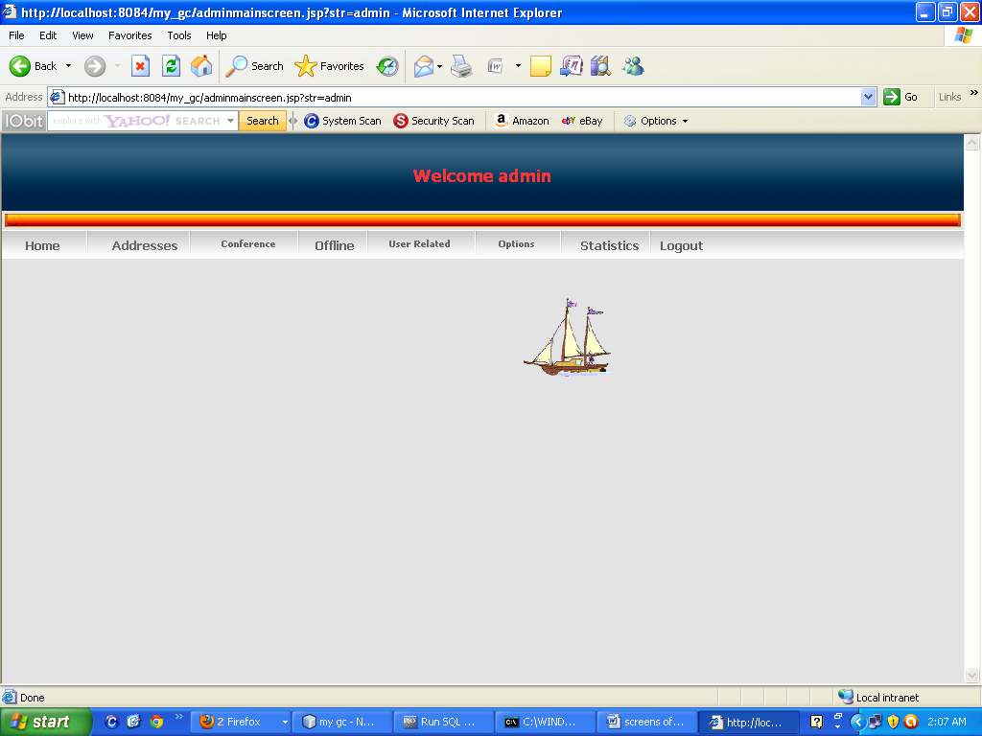

ADDRESS BOOK

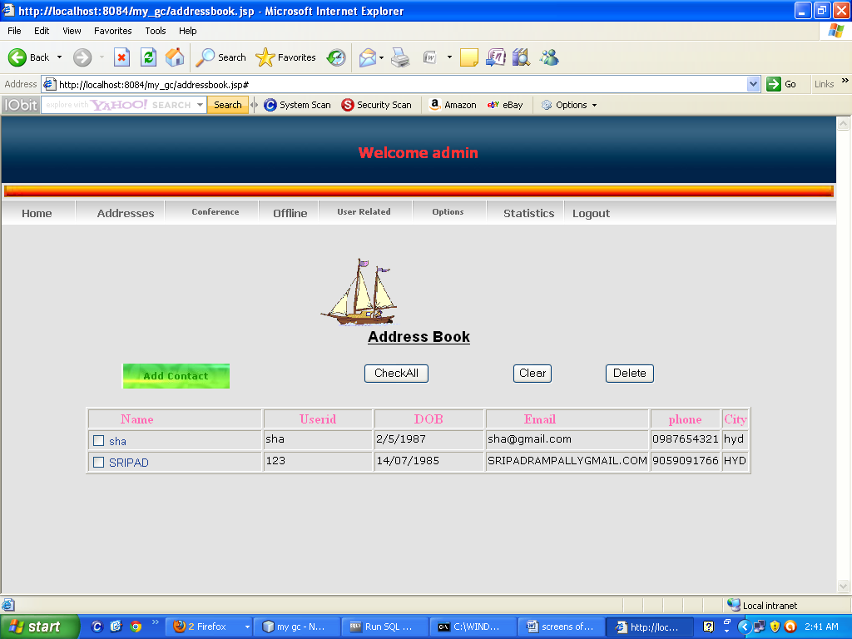

ADD TO THE ADDRESSBOOK

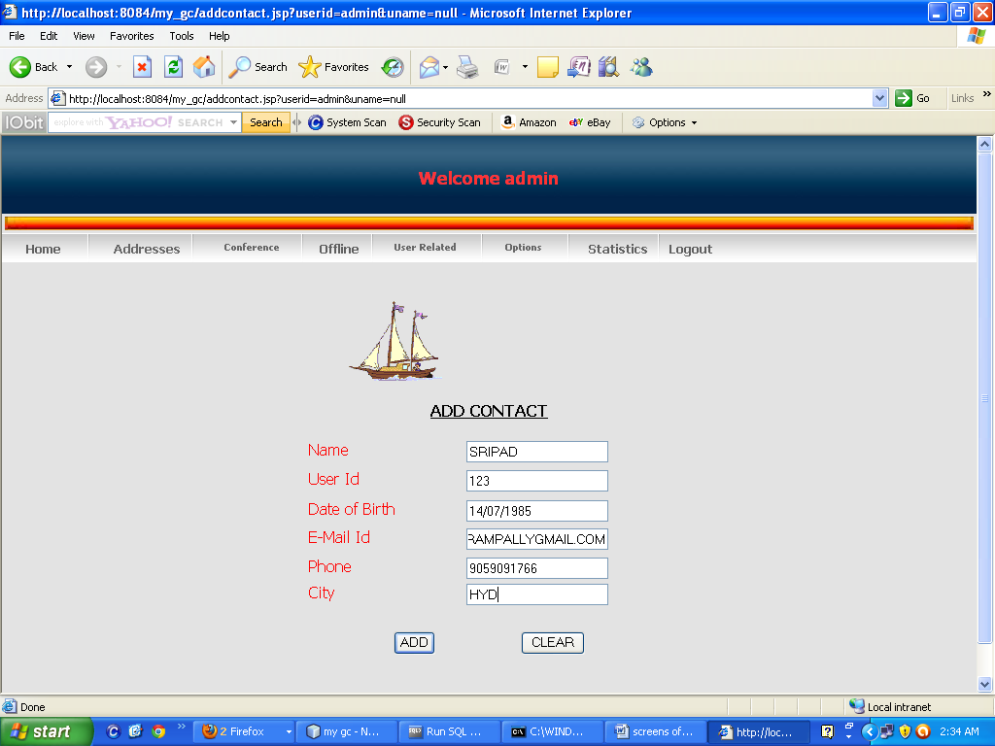

CREATION OF NEW ROOM

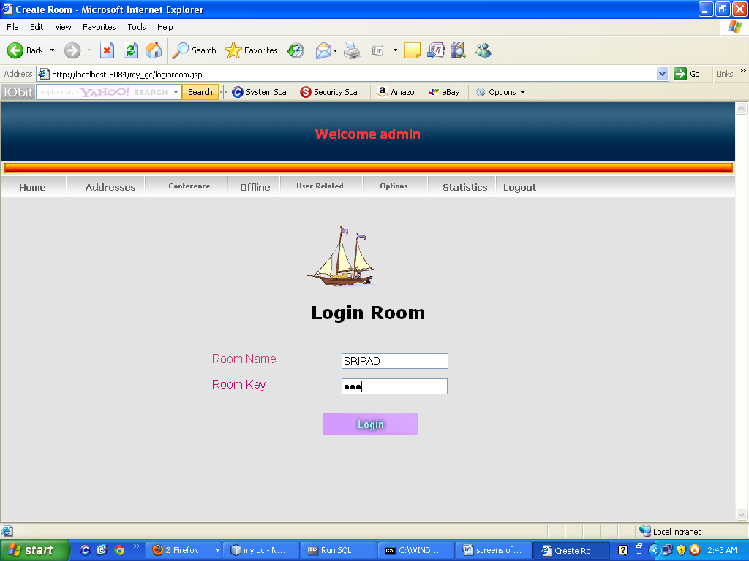

**Successfully Created:**

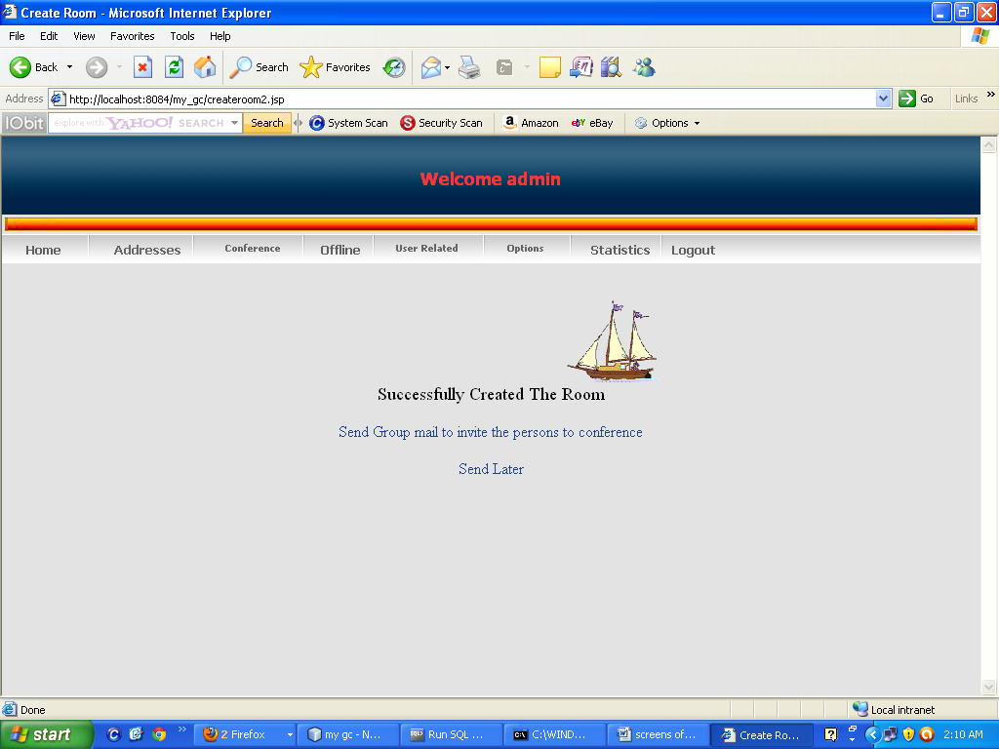

SENDING THE MESSAGE AFTER CREATION OF THE ROOM

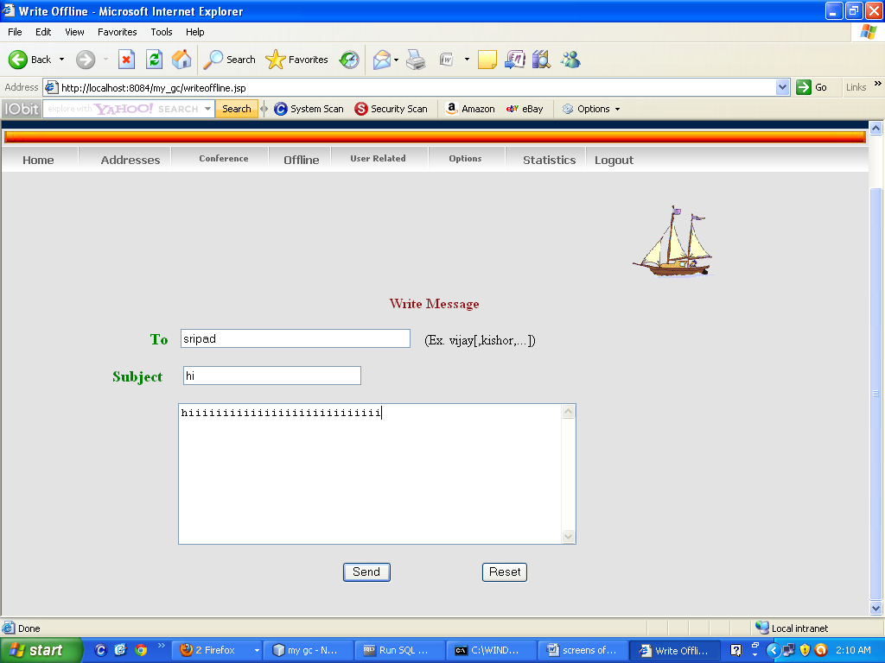

SUCCESS MESSAGE FOR SUCESSFULLY SENDED REPORT

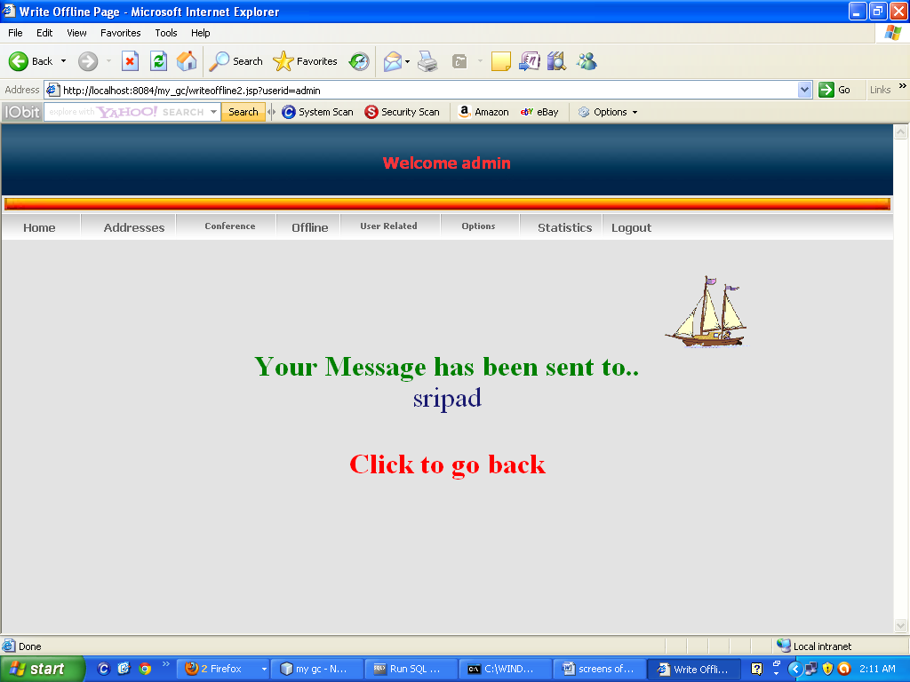

OFFLINE INFORMATION

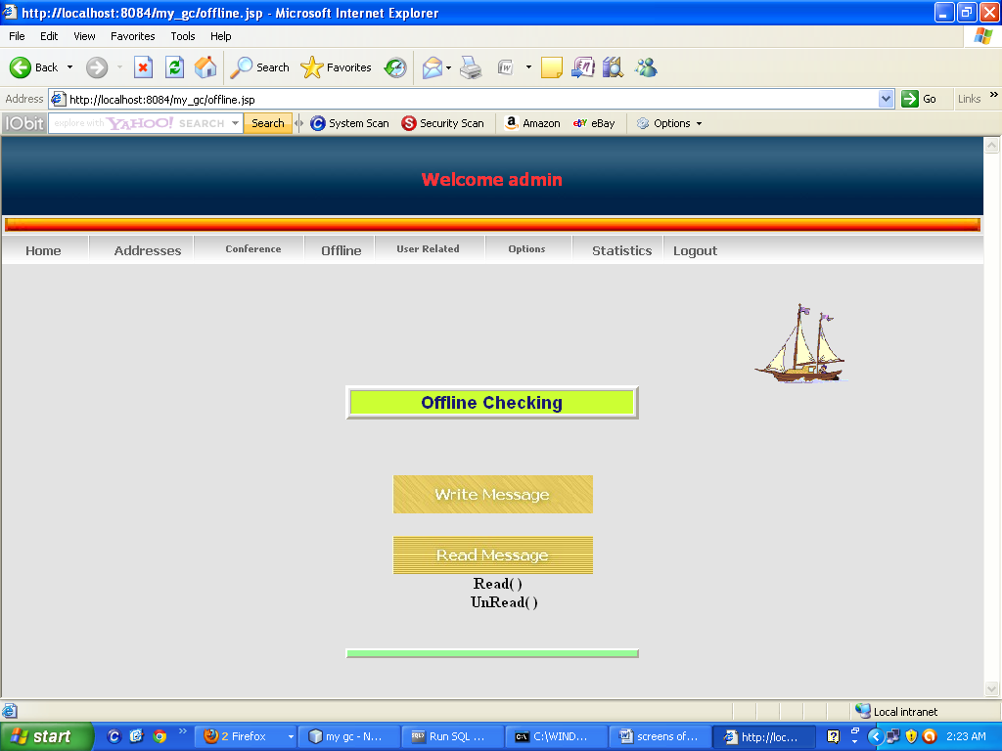

OFFLINE READING

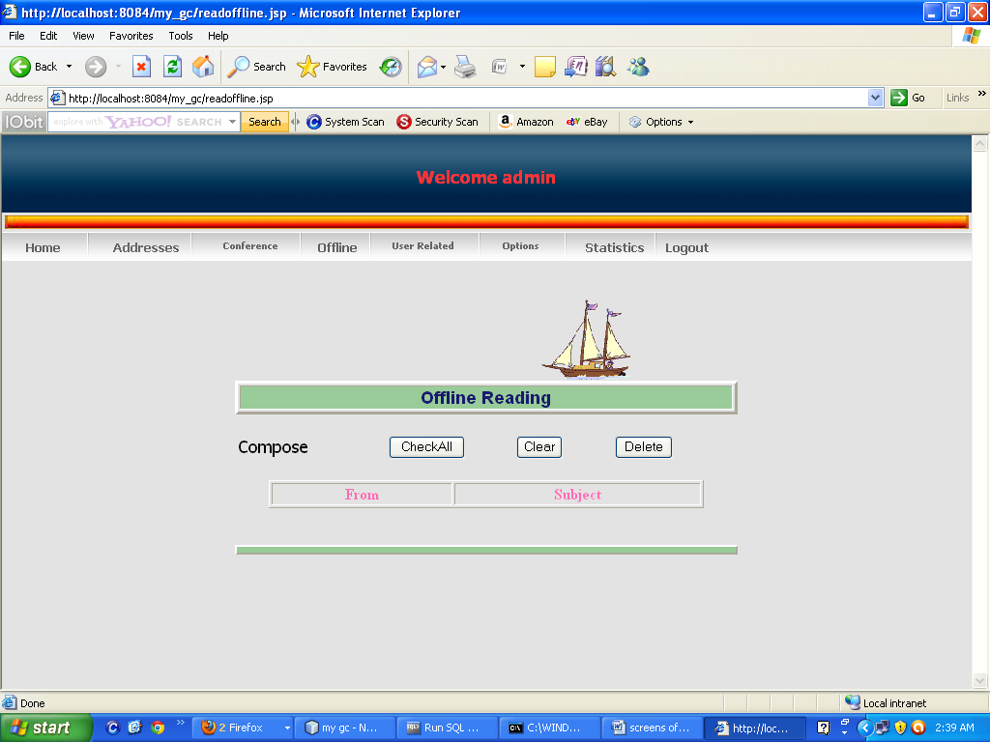

CONFRERANCE OPTIONS

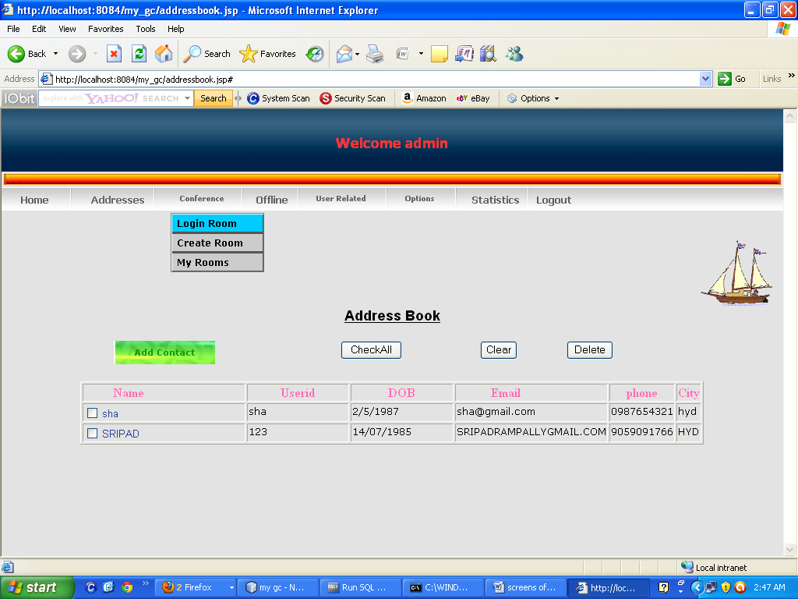

ALL THE CONFRERANCE ROOM DETAILS

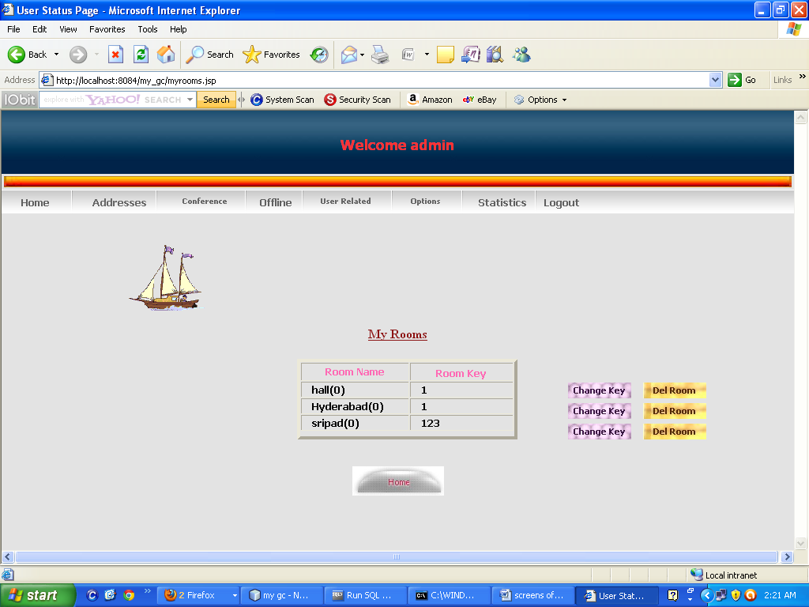

USER RELATED INFORMTION

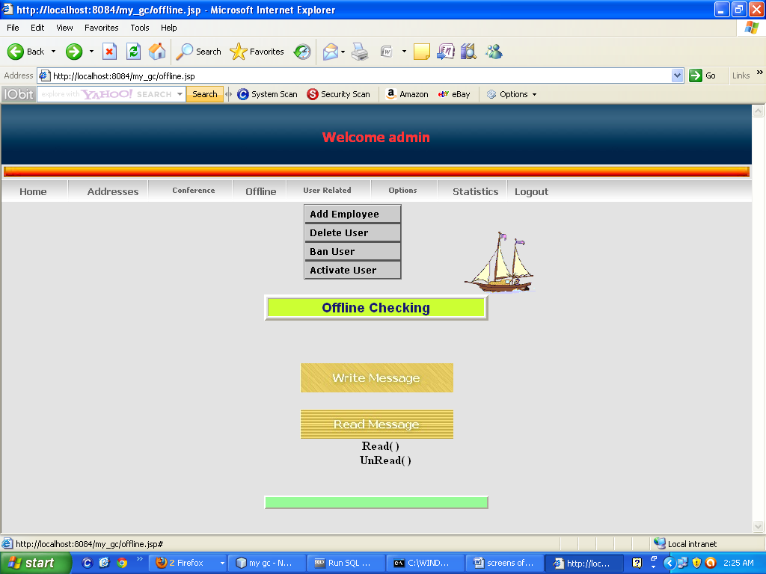

**ADD Employee STATUS:**

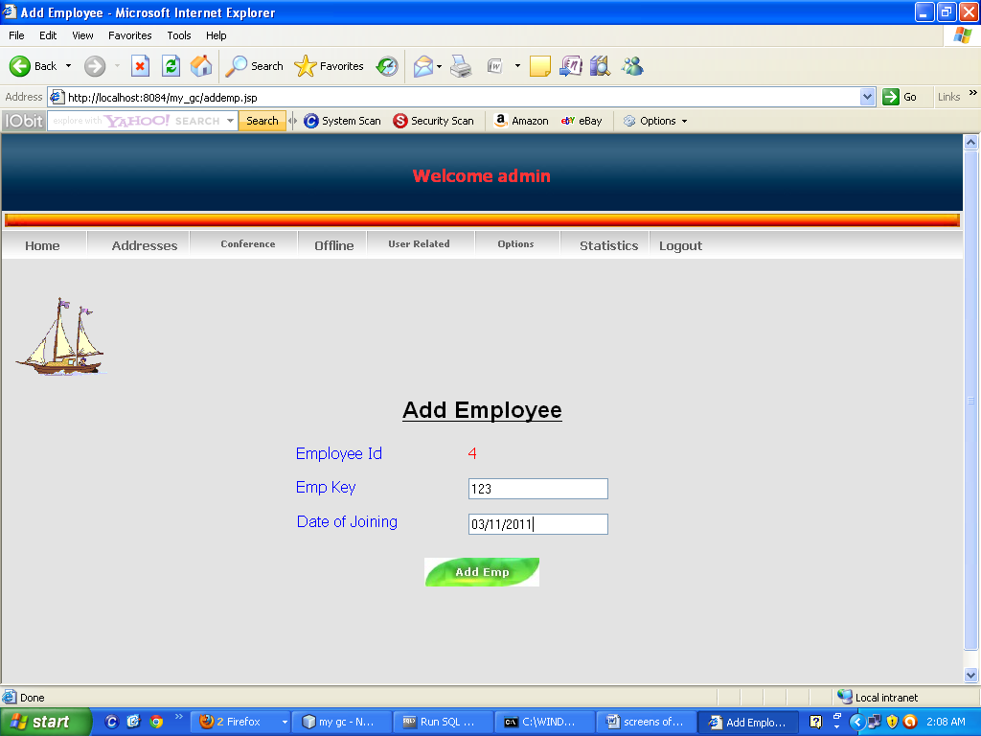

**VIEW PROFILE:**

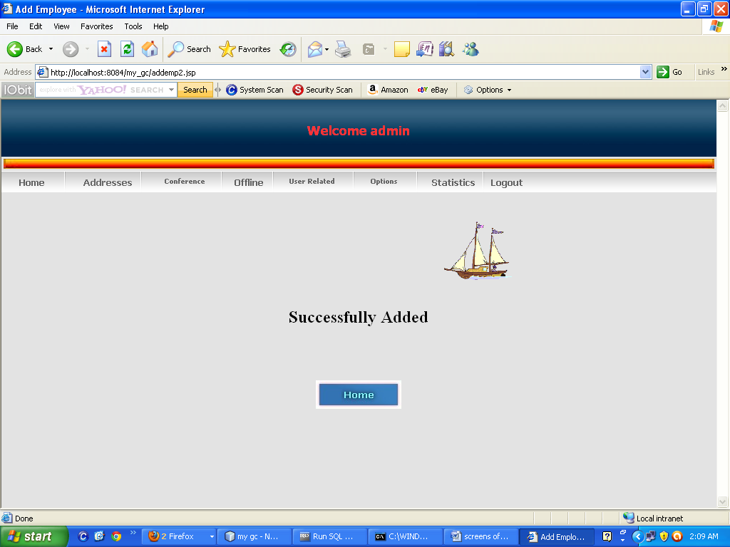

**VIEW USER PROFILE:**

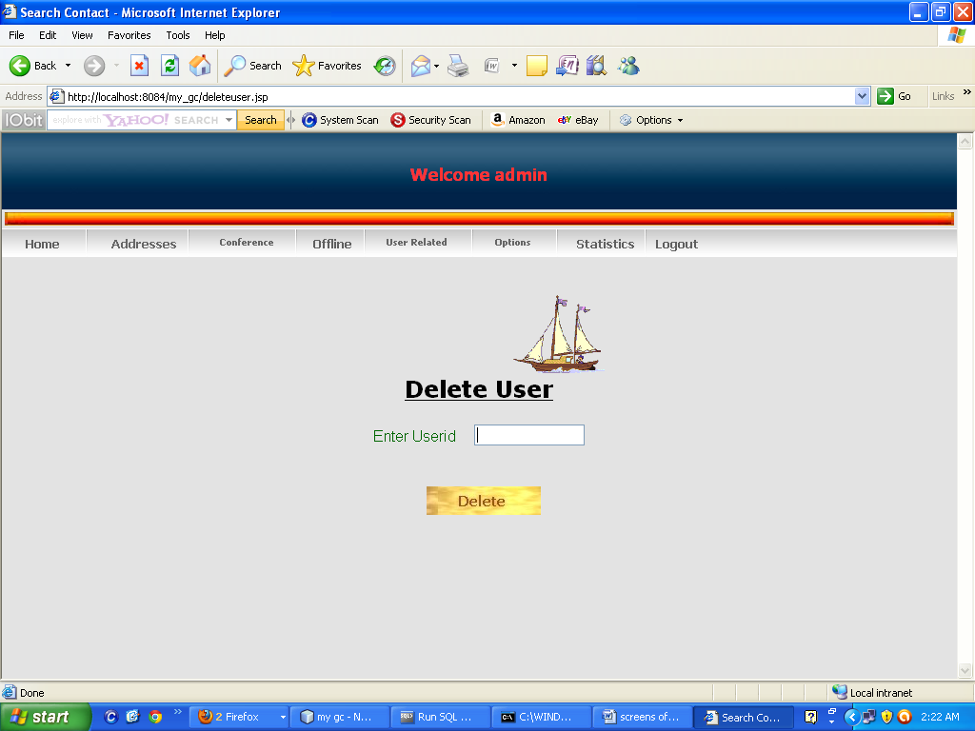

BAN USER

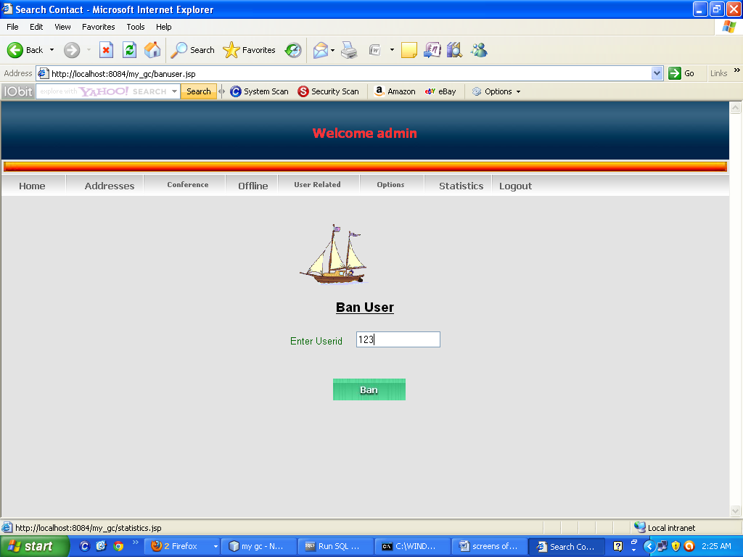

**ACTIVETE USER**

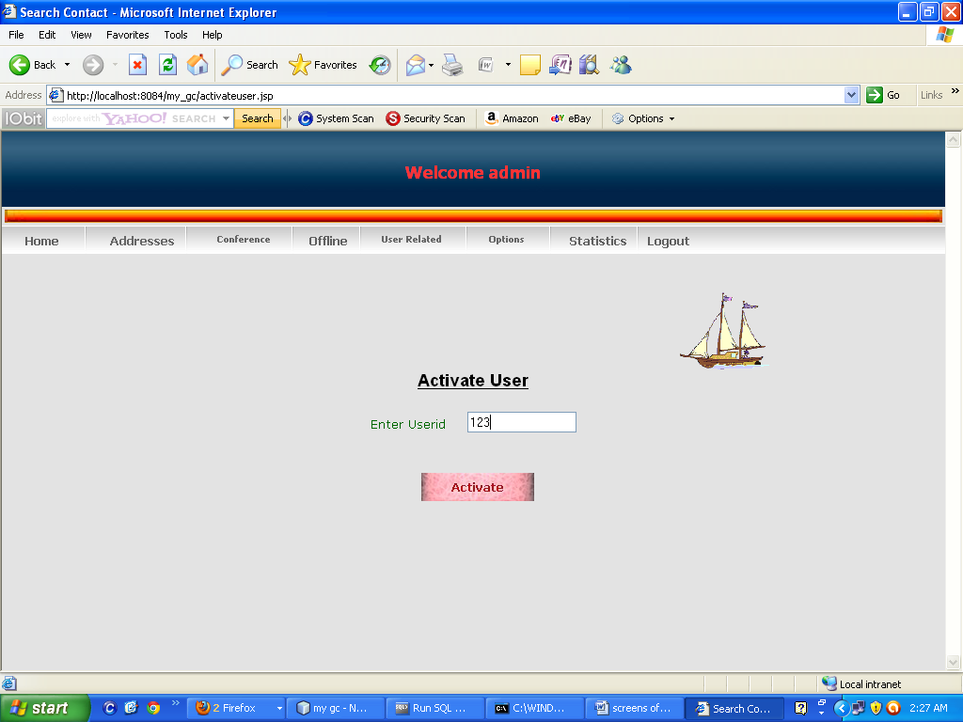

CHANGE PASSWORD

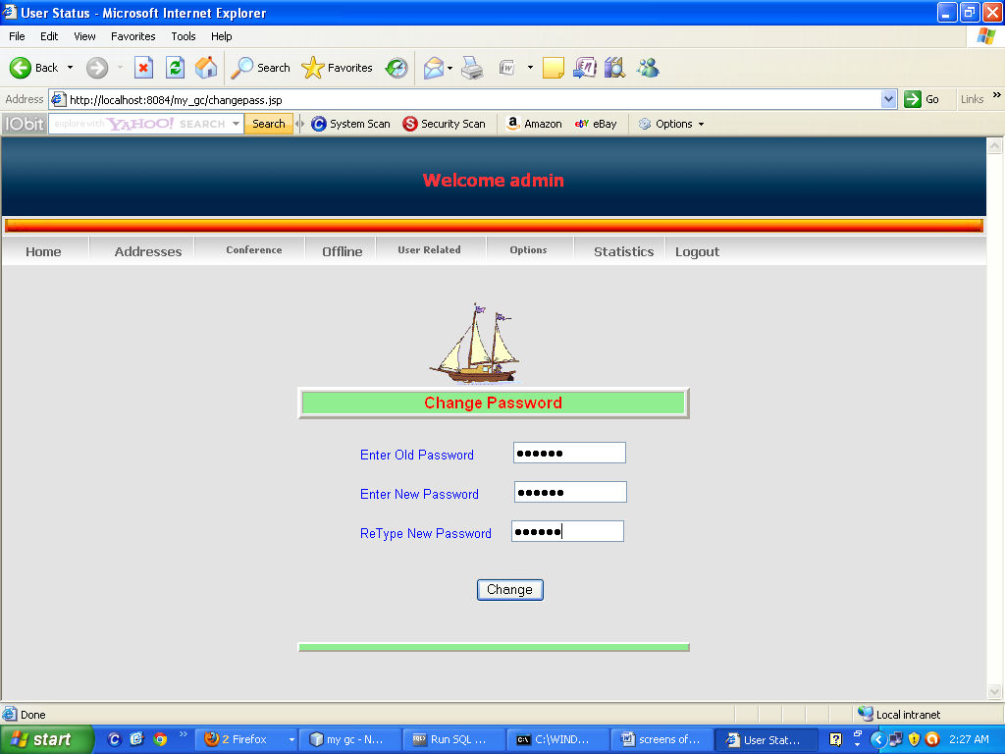

CHECK USER SATAUS

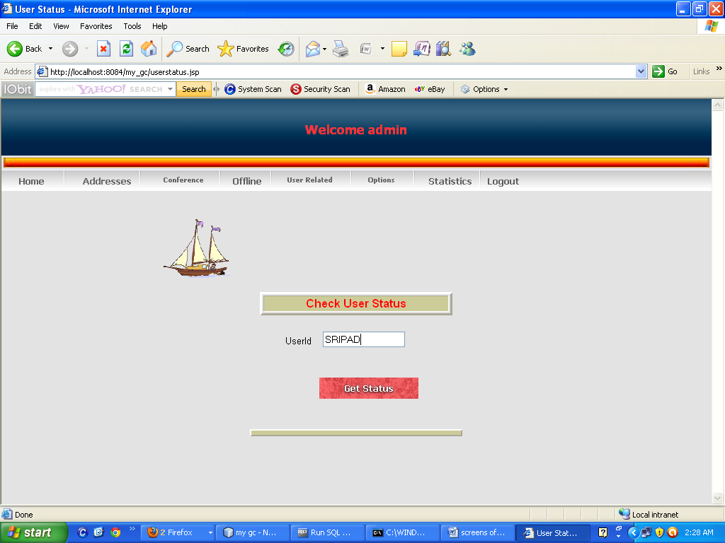

SERACH USER

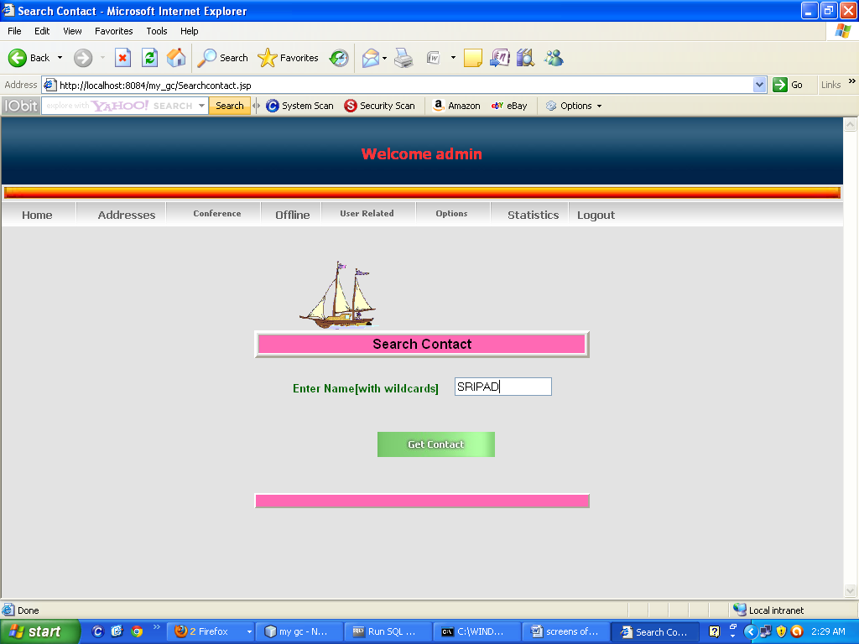

SUCCES MESS TO ADDBOOK ADDTION USERDETAILS

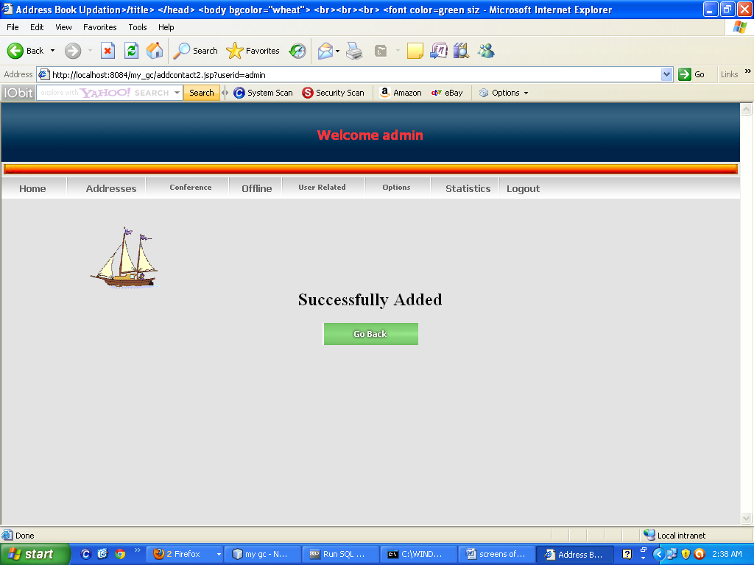

STATISTICS

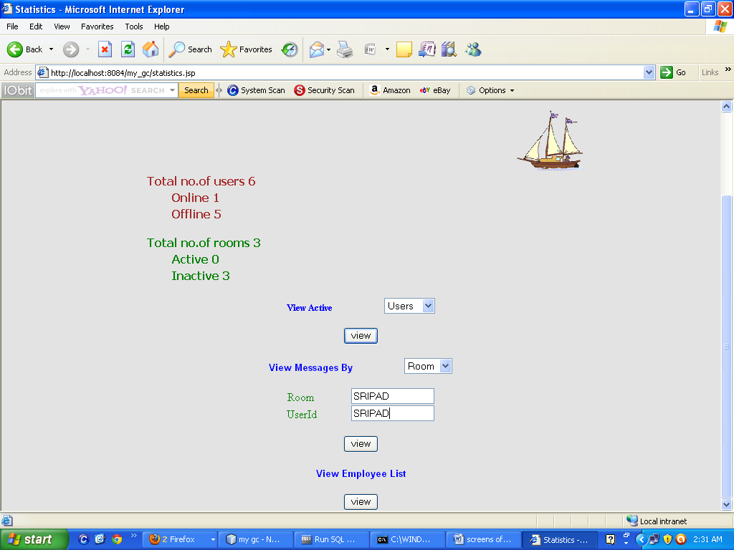

LOGOUT

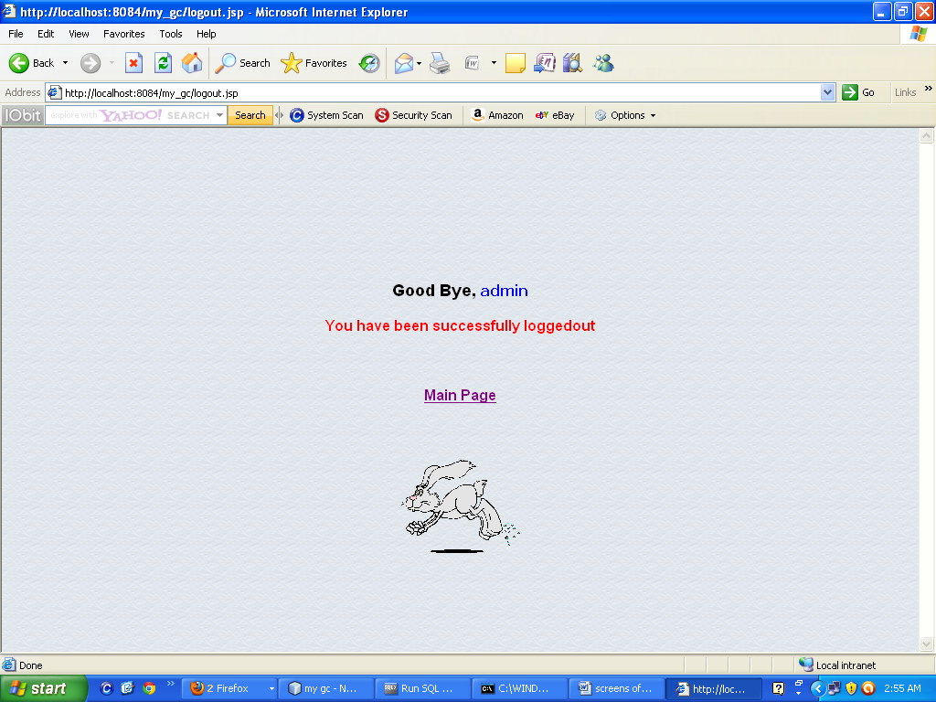

**Chapter 8**

**TESTING AND SYSTEM IMPLEMENTATION**

**8.1. INTRODUCTION**

Software testing is a critical element of software quality assurance and represents the ultimate review of specification, design and coding. In fact, testing is the one step in the software engineering process that could be viewed as destructive rather than constructive.

A strategy for software testing integrates software test case design methods into a well-planned series of steps that result in the successful construction of software. Testing is the set of activities that can be planned in advance and conducted systematically. The underlying motivation of program testing is to affirm software quality with methods that can economically and effectively apply to both strategic to both large and small-scale systems.

**SOFTWARE TESTING TECHNIQUES:**

Software testing is a critical element of software quality assurance and represents the ultimate review of specification, designing and coding.

TESTING OBJECTIVES:

1. Testing is process of executing a program with the intent of finding an error.
2. A good test case design is one that has a probability of finding an as yet undiscovered error.
3. A successful test is one that uncovers an as yet undiscovered error.

These above objectives imply a dramatic change in view port.

Testing cannot show the absence of defects, it can only show that software errors are present.

**TEST CASE DESIGN:**

Any engineering product can be tested in one of two ways:

1. White Box Testing: This testing is also called as glass box testing. In this testing, by knowing the specified function that a product has been designed to perform test can be conducted that demonstrates each function is fully operation at the same time searching for errors in each function. It is a test case design method that uses the control structure of the procedural design to derive test cases. Basis path testing is a white box testing.

Basis Path Testing:

1. Flow graph notation
2. Cyclomatic Complexity
3. Deriving test cases
4. Graph matrices

**Control Structure Testing:**

1. Condition testing
2. Data flow testing
3. Loop testing
4. Black Box Testing: In this testing by knowing the internal operation of a product, tests can be conducted to ensure that “ all gears mesh”, that is the internal operation performs according to specification and all internal components have been adequately exercised. It fundamentally focuses on the functional requirements of the software.

The steps involved in black box test case design are:

1. Graph based testing methods
2. Equivalence partitioning
3. Boundary value analysis
4. Comparison testing

SOFTWARE TESTING STRATEGIES:

A software testing strategy provides a road map for the software developer. Testing is a set of activities that can be planned in advance and conducted systematically. For this reason a template for software testing a set of steps into which we can place specific test case design methods should be defined for software engineering process. Any software testing strategy should have the following characteristics:

Testing begins at the module level and works “outward” toward the integration of the entire computer based system.

1. Different testing techniques are appropriate at different points in time.
2. The developer of the software and an independent test group conducts testing.
3. Testing and Debugging are different activities but debugging must be accommodated in any testing strategy.

Unit Testing: Unit testing focuses verification efforts in smallest unit of software design (module).

1. Unit test considerations
2. Unit test procedures

Integration Testing: Integration testing is a systematic technique for constructing the program structure while conducting tests to uncover errors associated with interfacing. There are two types of integration testing:

Top-Down Integration: Top down integration is an incremental approach to construction of program structures. Modules are integrated by moving down wards throw the control hierarchy beginning with the main control module.

1. Bottom-Up Integration: Bottom up integration as its name implies, begins construction and testing with automatic modules
2. Regression Testing: In this contest of an integration test strategy, regression testing is the re execution of some subset of test that have already been conducted to ensure that changes have not propagate unintended side effects.

**VALIDATION TESTING:**

At the culmination of integration testing, software is completely assembled as a package; interfacing errors have been uncovered and corrected, and a final series of software tests – *validation testing –* may begin. Validation can be fined in many ways, but a simple definition is that validation succeeds when software functions in a manner that can be reasonably expected by the customer.

Reasonable expectation is defined in the software requirement specification – a document that describes all user-visible attributes of the software. The specification contains a section titled “Validation Criteria”. Information contained in that section forms the basis for a validation testing approach.

VALIDATION TEST CRITERIA:

Software validation is achieved through a series of black-box tests that demonstrate conformity with requirement. A test plan outlines the classes of tests to be conducted, and a test procedure defines specific test cases that will be used in an attempt to uncover errors in conformity with requirements. Both the plan and procedure are designed to ensure that all functional requirements are satisfied; all performance requirements are achieved; documentation is correct and human-engineered; and other requirements are met.

After each validation test case has been conducted, one of two possible conditions exists: (1) The function or performance characteristics conform to specification and are accepted, or (2) a deviation from specification is uncovered and a deficiency list is created. Deviation or error discovered at this stage in a project can rarely be corrected prior to scheduled completion. It is often necessary to negotiate with the customer to establish a method for resolving deficiencies.

CONFIGURATION REVIEW:

An important element of the validation process is a *configuration review*. The intent of the review is to ensure that all elements of the software configuration have been properly developed, are catalogued, and have the necessary detail to support the maintenance phase of the software life cycle. The configuration review sometimes called an audit.

Alpha and Beta Testing:

It is virtually impossible for a software developer to foresee how the customer will really use a program. Instructions for use may be misinterpreted; strange combination of data may be regularly used; and output that seemed clear to the tester may be unintelligible to a user in the field.

When custom software is built for one customer, a series of acceptance tests are conducted to enable the customer to validate all requirements. Conducted by the end user rather than the system developer, an acceptance test can range from an informal “test drive” to a planned and systematically executed series of tests. In fact, acceptance testing can be con

**8.2. STRATEGIC APPROACH TO SOFTWARE TESTING**

The software engineering process can be viewed as a spiral. Initially system engineering defines the role of software and leads to software requirement analysis where the information domain, functions, behavior, performance, constraints and validation criteria for software are established. Moving inward along the spiral, we come to design and finally to coding. To develop computer software we spiral in along streamlines that decrease the level of abstraction on each turn.

A strategy for software testing may also be viewed in the context of the spiral. Unit testing begins at the vertex of the spiral and concentrates on each unit of the software as implemented in source code. Testing progress is done by moving outward along the spiral to integration testing, where the focus is on the design and the construction of the software architecture. Talking another turn on outward on the spiral we encounter validation testing where requirements established as part of software requirements analysis are validated against the software that has been constructed. Finally we arrive at system testing, where the software and other system elements are tested as a whole

UNIT TESTING

MODULE TESTING

SUB-SYSTEM TESING

SYSTEM TESTING

ACCEPTANCE TESTING

Component Testing

Integration Testing

User Testing

**8.3. Unit Testing**

Unit testing focuses verification effort on the smallest unit of software design, the module. The unit testing we have is white box oriented and some modules the steps are conducted in parallel.

**1. WHITE BOX TESTING**

This type of testing ensures that

* All independent paths have been exercised at least once
* All logical decisions have been exercised on their true and false sides
* All loops are executed at their boundaries and within their operational bounds
* All internal data structures have been exercised to assure their validity.

To follow the concept of white box testing we have tested each form .we have created independently to verify that Data flow is correct, All conditions are exercised to check their validity, All loops are executed on their boundaries.

**2. BASIC PATH TESTING**

Established technique of flow graph with Cyclamate complexity was used to derive test cases for all the functions. The main steps in deriving test cases were:

Use the design of the code and draw correspondent flow graph.

Determine the Cyclamate complexity of resultant flow graph, using formula:

V(G)=E-N+2 or

V(G)=P+1 or

V(G)=Number Of Regions

Where V(G) is Cyclamate complexity,

E is the number of edges,

N is the number of flow graph nodes,

P is the number of predicate nodes.

Determine the basis of set of linearly independent paths.

**3. CONDITIONAL TESTING**

In this part of the testing each of the conditions were tested to both true and false aspects. And all the resulting paths were tested. So that each path that may be generate on particular condition is traced to uncover any possible errors.

**4. DATA FLOW TESTING**

This type of testing selects the path of the program according to the location of definition and use of variables. This kind of testing was used only when some local variable were declared. The *definition-use chain* method was used in this type of testing. These were particularly useful in nested statements.

**5. LOOP TESTING**

In this type of testing all the loops are tested to all the limits possible. The following exercise was adopted for all loops:

* All the loops were tested at their limits, just above them and just below them.
* All the loops were skipped at least once.
* For nested loops test the inner most loop first and then work outwards.
* For concatenated loops the values of dependent loops were set with the help of connected loop.
* Unstructured loops were resolved into nested loops or concatenated loops and tested as above.

**8.4. Test Cases**

Test Case Report1

(Use one template for each test case)

|  |  |  |  |
| --- | --- | --- | --- |
| **GENERAL INFORMATION** | | | |
| **Test Stage:** | Unit Functionality Interface  Performance Acceptance | | |
| **Test Date:** | 27/08/2011 | **System Date, if applicable:** | 27/08/2011 |
| **Tester:** | ANIL KUMAR | **Test Case Number:** | 1 |
| **Test Case Description:** | Unit testing focuses on verifying the effort on the smallest unit of software-module. The local data structure is examined to ensure that the date stored temporarily maintains its integrity during all steps in the algorithm’s execution. Boundary conditions are tested to ensure that the module operates properly at boundaries established to limit or restrict processing. | | |
| **Results:** | Pass(OK) Fail |
| **INTRODUCTION** | | | |
| **Requirement(s) to be tested:** | Username Text field and Password Text field and the Authority Text Area. | | |
| **Roles and Responsibilities:** | Gathering the Requirements of the Project Designing and Testing. | | |
| **Set Up Procedures:** | By Installing Net Beans. | | |
| **ENVIRONMENTAL NEEDS** | | | |
| **Hardware:** | PC with Minimum 20GB Hard Disk and 1GB RAM. | | |
| **Software:** | Windows XP/2000, ORACLE, Net Beans IDE 6.0. | | |
| **TEST** | | | |
| **Test Items and Features:** | Username and Password. | | |
| **Procedural Steps:** | If the User enters the correct username and password it will be redirected to another appropriate page so that we can confirm test is accepted. | | |
| **Expected Results of Case:** | If the page is redirected we can confirm the result of this Test case is succeeded. | | |

Test Case Report2

(Use one template for each test case)

|  |  |  |  |
| --- | --- | --- | --- |
| **GENERAL INFORMATION** | | | |
| **Test Stage:** | Unit Functionality Interface  Performance Acceptance | | |
| **Test Date:** | 27/08/2011 | **System Date, if applicable:** | 27/08/2011 |
| **Tester:** | ANIL KUMAR | **Test Case Number:** | 2 |
| **Test Case Description:** | Unit testing focuses on verifying the effort on the smallest unit of software-module. The local data structure is examined to ensure that the date stored temporarily maintains its integrity during all steps in the algorithm’s execution. Boundary conditions are tested to ensure that the module operates properly at boundaries established to limit or restrict processing. | | |
| **Results:** | Pass(OK) Fail |
| **INTRODUCTION** | | | |
| **Requirement(s) to be tested:** | The registered Details should match with corresponding student ID and Password, time table creation ,view lecture login details, view student details.. | | |
| **Roles and Responsibilities:** | Gathering the Requirements of the Project Designing and Testing. | | |
| **Set Up Procedures:** | By Installing NetBeans. | | |
| **ENVIRONMENTAL NEEDS** | | | |
| **Hardware:** | PC with Minimum 20GB Hard Disk and 1GB RAM. | | |
| **Software:** | Windows XP/2000, ORACLE, Net Beans IDE 6.0. | | |
| **TEST** | | | |
| **Test Items and Features:** | View Assignment ,exam schedule…. | | |
| **Procedural Steps:** | If the User enters the correct username and password it will be redirected to another appropriate page so that we can confirm test is accepted. | | |
| **Expected Results of Case:** | If the page is redirected we can confirm the result of this Test case is succeeded. | | |

**Chapter 9**

**System Security**

# 9.1. Introduction

The protection of computer based resources that includes hardware, software, data, procedures and people against unauthorized use or natural

Disaster is known as System Security.

System Security can be divided into four related issues:

* Security
* Integrity
* Privacy
* Confidentiality

**SYSTEM SECURITY** refers to the technical innovations and procedures applied to the hardware and operation systems to protect against deliberate or accidental damage from a defined threat.

**DATA SECURITY** is the protection of data from loss, disclosure, modification and destruction.

**SYSTEM INTEGRITY** refers to the power functioning of hardware and programs, appropriate physical security and safety against external threats such as eavesdropping and wiretapping.

**PRIVACY** defines the rights of the user or organizations to determine what information they are willing to share with or accept from others and how the organization can be protected against unwelcome, unfair or excessive dissemination of information about it.

**CONFIDENTIALITY** is a special status given to sensitive information in a database to minimize the possible invasion of privacy. It is an attribute of information that characterizes its need for protection.

## 9.2. SECURITY IN SOFTWARE

System security refers to various validations on data in form of checks and controls to avoid the system from failing. It is always important to ensure that only valid data is entered and only valid operations are performed on the system. The system employees two types of checks and controls:

**CLIENT SIDE VALIDATION**

Various client side validations are used to ensure on the client side that only valid data is entered. Client side validation saves server time and load to handle invalid data. Some checks imposed are:

* JavaScript in used to ensure those required fields are filled with suitable data only. Maximum lengths of the fields of the forms are appropriately defined.
* Forms cannot be submitted without filling up the mandatory data so that manual mistakes of submitting empty fields that are mandatory can be sorted out at the client side to save the server time and load.
* Tab-indexes are set according to the need and taking into account the ease of user while working with the system.

**SERVER SIDE VALIDATION**

Some checks cannot be applied at client side. Server side checks are necessary to save the system from failing and intimating the user that some invalid operation has been performed or the performed operation is restricted. Some of the server side checks imposed is:

* Server side constraint has been imposed to check for the validity of primary key and foreign key. A primary key value cannot be duplicated. Any attempt to duplicate the primary value results into a message intimating the user about those values through the forms using foreign key can be updated only of the existing foreign key values.
* User is intimating through appropriate messages about the successful operations or exceptions occurring at server side.
* Various Access Control Mechanisms have been built so that one user may not agitate upon another. Access permissions to various types of users are controlled according to the organizational structure. Only permitted users can log on to the system and can have access according to their category. User- name, passwords and permissions are controlled o the server side.
* Using server side validation, constraints on several restricted operations are imposed.

**Chapter 10**

**CONCLUSION**

**CONCLUSION**

The objective of this project is to conduct conferences on the Internet or Intranet. Instead of conducting conferences in some places by using this project they can participate in conference in their house itself by using their PC.

By using this project they can

* Conduct conferences with their employees. So they can get online decisions from employees from the different branches of the company.
* The another advantage is that the company is having branches throughout the country. So this will help them to communicate business affairs of the company and live meetings and conferences between their directors. They can conduct board of directors meeting.
* It will give On-line solutions from the superiors to the employees.

Likely there are so many advantages by developing this conference on the net.

**Chapter 11**

**FUTURE ENHANCEMENT**

The efficiency of any system designed to suit an organization depends cooperation during the implementation stage and also flexibility of the system to adopt itself to the organization. **“Online meeting Media”** has been developed to overcome the problems with in developing the conference on the net.

* In future this project offers user to enter the data through simple and interactive forms.
* This is very helpful for the client to enter the desired information through so much simplicity.
* The user is mainly more concerned about the validity of the data, whatever he is entering. There are checks on every stages of any new creation, data entry or updating so that the user cannot enter the invalid data, which can create problems at later date.

**BIBLIOGRAPHY**

BIBLIOGRAPHY

* Patrick Naughton and Herbert Shildt , “ The complete reference Java 2.0.
* Joseph L. weber, ‘ Using Java 2.0 ‘ , PHI Publishers.
* Karl Moss, ‘ Java Servlets ‘.
* Jason Hunter with William Crawford , ‘Java Servlet Programming ‘ SPD publications.
* Java Server Pages Book by Wrox Publications
* SQL Complete Reference by Liviol.
* HTML Black Book by Holzner.
* JDBC Programming by Patel Moss
* Tom Negrino and Dori smith, “ Java Script For The world Wide Web”.
* Roger S Pressman, ‘ Software Engineering’ , McGraw Hill Inc., 3rd Edition, 19998.
* Jeffrey Ritcher, ‘Advanced Windows NT’, Microsoft Press, 1998.

David A. Solomon, ‘Inside Windows NT’, Microsoft Press, Second Edition-1998